Arpit Maheshwari  Principal Product Designer (UX / UI) (+91) 8983092531 | ArpitMaheshwari.com maheshwari.arpit88@gmail.com  LinkedIn Medium GitHub

About Me
With over 15 years of experience, I specialize in transforming complex, unstructured systems into high-performance, AI-driven digital architectures. Unlike traditional designers, my approach is rooted in "Predictability over Creativity," ensuring every design decision impacts the bottom line. Proven track record of delivering massive scale—from processing 50 million bids per hour in AdTech to securing $1M in annual operational savings in EdTech. I don’t just build products; I engineer financial efficiency and scalable growth.
- End-to-End Product Lifecycle: Adept at formulating strategy, designing solutions, and guiding products from initial concept through to enterprise-scale deployment.
- MVP to Enterprise Growth: Proven ability to steer products from their minimum viable stage (0→1) to broad market adoption and scalability (1→n).
- TechnoUX Expertise: Bridge between technical development and user experience, especially for deep tech projects demanding robust usability and adoption.
- Enable Product Adoption: I champion a feedback-loop-driven methodology, leveraging real user insights to refine products continuously and make sure they get adopted.
- Multi-Industry Domain Knowledge: AdTech (Out-of-Home Media), EdTech, Manufacturing, FinTech, Pharmaceuticals, Telecommunications, HR Operations, Loyalty Solutions and more.

Design skills  Design Strategy & Leadership  Systems Thinking  Product Design  User Experience Design (UX/UI)  Interaction Design (IxD)  User Research & Testing | Execution skills  Systems Thinking  Pattern Recognition  Cross-functional Agile  ROI-Centric Product Strategy  Scalable Design Governance  Stakeholder Alignment | Tools  Figma, Adobe XD,  Illustrator, Balsamiq  Gen AI Tools  HTML5 / CSS3  CMS / SEO  Web Accessibility

Work Experience

Sahaj AI Software Solutions Pvt. Ltd., Remote, India, sahaj.ai

Designation: Solution Consultant - December 2019 - Present
I led the strategy and design initiatives as a consultant, developing disruptive, AI-driven solutions for sectors including AdTech, HRTech, and Private Equity.

PTC Inc., Pune, India, ptc.com

Designation: Technical Lead - March 2014 - December 2019
Led the strategy and design for the customer experience of PTC University’s EdTech solutions, serving over 350,000+ active users and attracting 550,000+ annual visits. The platform was used by organizations like NASA, Toyota, GE, Boeing, Airbus, Apple, Samsung, and Vertu.

As the first design professional at PTC University India, I spent six years building the UX/UI development function into a distributed, multi-functional Customer Experience (CX) team.

Equal Experts, Pune, India, equalexperts.com

Designation: Front End Specialist - December 2012 - March 2014
Drove customer retention, boosted engagement, and fostered brand loyalty for O2 in the UK by developing loyalty and rewards solutions for over one million subscribers.

Tata Consultancy Services, Pune, India, tcs.com

Designation: Systems Analyst - September 2010 - December 2012
I contributed to TCS’s mobility division, where I developed a range of mobile solutions for Fortune 500 clients in both the banking and pharmaceutical sectors.

Nokia Networks (Internship), Indore, India, nokia.com

Designation: Intern - May 2009 - June 2009

Education

Institute of Management Technology, Center for Distance Learning, Ghaziabad, India

Executive MBA in Business Analytics, July 2017 - June 2018

Shri Vaishnav Institute of Technology and Science, Indore, India

Bachelor of Engineering in Electronics and Communication, July 2006 - June 2010

Design Process

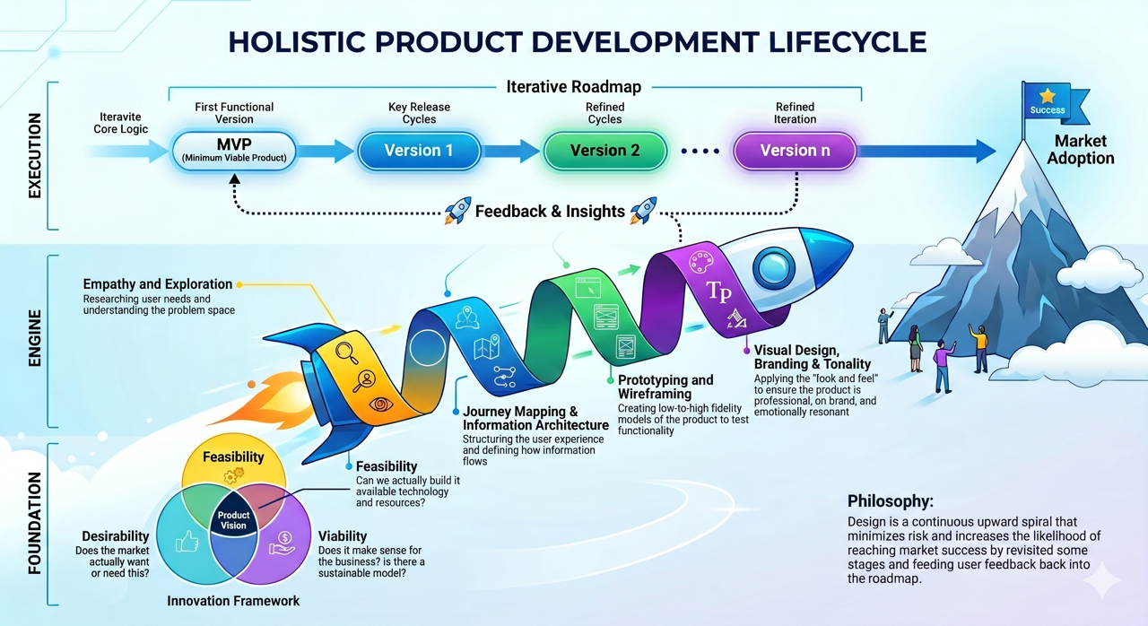

Framework to introduce AI in your business

 | Transformation | Outcome | Key Benefit
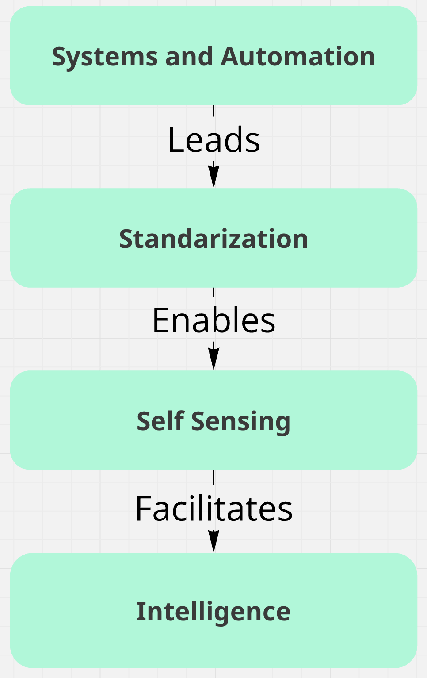 | System → Standardisation | Unifies processes, protocols, and interfaces | Consistency, scalability
 | Standardisation → Sensing | Enables devices to reliably monitor and communicate status | Accurate, interoperable self-monitoring
 | Sensing → Intelligence | Leverages sensing to power data-driven analytics and actions | Emergent intelligence, optimization, autonomy

Case Study: AlphaDeals
Designing "Decision-Grade" Trust in Generative AI - Agentic AI & Enterprise Predictability

Role: Designer and Strategist (Nov 2025), collaborating remotely with a distributed cross functional agile team
https://AlphaDeals.ai

Summary
Core Focus: AI Governance, Hallucination Mitigation, and "Predictability over Creativity"

The Challenge
In enterprise environments, Generative AI’s inherent unpredictability and tendency to hallucinate are critical liabilities. The objective was to architect an AI-driven deal-finding platform where absolute accuracy, operational security, and user trust strictly superseded creative, open-ended generation.

The Strategy & Execution
I championed a rigid "Predictability over Creativity" design philosophy. Instead of designing a conventional conversational chatbot, I structured the system as a highly governed Agentic Architecture with strict operational boundaries.

The Reasoning Trail (Algorithmic Transparency): I engineered an interface that systematically exposes the AI’s decision-making logic. By transitioning the AI from a "black box" to a transparent, auditable process, users can instantly verify how the system arrived at a specific deal recommendation.

Confidence Visualization: Designed advanced UX parameters that explicitly visualize the AI's confidence levels for every data output. This proactive risk-mitigation strategy manages user expectations in real-time and neutralizes the impact of potential algorithmic edge-cases.

The Impact
Successfully transformed an unpredictable Large Language Model (LLM) into a highly reliable, enterprise-grade business tool. By prioritizing system governance, transparent logic, and zero-compromise reliability, this architecture established a scalable, fail-safe foundation for future AI product integrations.

The Context: A Strategic Design Imperative

AlphaDeals represents a strategic effort by Mayfair Equity Partners to position itself at the forefront of private equity innovation through the integration of advanced data and AI technologies. As the industry evolves into a data-centric discipline, the ability to harness sophisticated analytics has become a critical differentiator for securing competitive advantage and maintaining Limited Partner (LP) confidence.

The design mandate was clear: respond to the industry imperative for a unified, intelligent system capable of streamlining workflows and delivering actionable insights. The product needed to combine internal and external data with cutting-edge AI to unlock value, mitigate risks, and sustain long-term growth.

Key Capabilities Designed:

AI-Driven Insights: Analyzing deal performance and management quality

Automated Document Processing: Reducing manual effort and improving accuracy.

Predictive Analytics: Anticipating risks and opportunities to enhance decision precision.

The User Problem: The "Consistency Gap"

The design journey began by acknowledging a failure in standard AI interfaces. While early prototypes using "off-the-shelf" LLMs (like ChatGPT) were impressive and produced "exquisitely crafted" responses , they failed when faced with real institutional workloads.

From a User Experience (UX) perspective, the investment team faced a critical Crisis of Reliability:

Fluency v/s Reliability: Users found that while LLMs were excellent at language, they were inconsistent at logic. The interface would generate confident, fluent responses that were not necessarily verified.

The "Black Box" Anxiety: Users were presented with opaque reasoning where "no explicit logic trail" was visible. This lack of traceability made the output unusable for auditable investment decisions.

Workflow Friction: Valuable deal data was trapped in silos like email inboxes. The lack of an integrated system meant users had to manually bridge the gap between communication and data storage, leading to fragmented insights.

The Product Goal: The challenge was to move the user experience from "Conversation" (exploratory, creative) to "Conviction" (auditable, structured, evidence-based).

The Design Philosophy: "Agentic" & Transparent

To solve the trust gap, the product team rejected the standard "chatbot" paradigm. Instead, they designed an Agentic Architecture—a distributed system where specialized components act as an "orchestra" rather than a single improvising soloist.

Design Principle 1: Transparency over Simplicity

Standard AI interfaces prioritize simple answers. AlphaDeals prioritizes traceability.

The "Reasoning Trail": The interface was designed to expose the process. Every evaluation carries an explicit reasoning trail, showing the user exactly which data was used, which rules were triggered, and the confidence levels at each step.

Visualizing Confidence: The design integrates "confidence management." If the system’s confidence falls below a set threshold, the workflow automatically routes the case for human review, integrating failure states gracefully into the user journey.

Design Principle 2: Intelligence That Compounds

A core tenet of the interaction design is that the intention is not to eliminate human judgement. It is to capture it, structure it and make it reusable.

The Feedback Loop: When a user corrects the system or provides an "expert override," the interface captures this as structured data.

Institutional Memory: The system’s memory grows with every interaction. Over time, the product evolves to reflect how the organization thinks, creating a defensible advantage based on accumulated institutional knowledge.

Design Principle 3: Predictability over Creativity

The design actively constrains the model to ensure reliability in high-stakes decisions.

The Constraint: In creative contexts, flexibility is useful; in capital allocation, it is a liability. The product imposes "deterministic logic overlays" on top of the probabilistic model to prevent hallucination.

The Outcome: The aim is not to make the model more creative, but to make the overall system more predictable. The interface ensures that identical inputs always produce consistent, reproducible results, solving the "context drift" common in native LLMs.

Interaction Design: Solving the Workflow

The product design focused heavily on removing friction from the high-volume environment of deal origination.

The "Zero-Friction" Sidecar

The Friction: Users were ignoring data entry because it disrupted their flow.

The Solution: An in-line Outlook integration that functions as a "sidecar" to the user's daily communication.

Interaction: Users can tag emails and "drag-and-drop" attachments (PDFs, Excel) directly into the AlphaDeals panel without leaving Outlook.

Immediate Feedback: The interface provides instant confirmation ("Received, thanks") while background agents automatically stitch the unstructured data into a unified profile.

Contextual Insight: As soon as an email is processed, the design surfaces a "Prequalification Score" directly in the inbox, allowing the user to make an immediate prioritization decision.

Visualizing the Invisible: The Leadership Scorecard

The Friction: Assessing management quality is notoriously subjective and relies on "gut feel".

The Solution: A dashboard that renders leadership as a measurable, visual asset.

Data Synthesis: The UI aggregates disparate signals—LinkedIn tenure, Glassdoor sentiment, and Companies House financial history—into a single visual timeline.

Comparative Benchmarking: The design places these metrics against industry norms, giving users a clear visual anchor for "good" vs. "risky" leadership.

Quantified Confidence: The scoring model reduces reliance on subjective judgment by providing a quantifiable proxy for success.

The Transformation: How Design Reshaped the Firm

The introduction of AlphaDeals went beyond a simple software upgrade; the design strategy catalyzed a fundamental shift in the organization's operating model. By structuring the product around governance and learning rather than just "automation," the design delivered three transformational outcomes:

A. Institutionalizing Intuition (The "Memory" Shift)

Before AlphaDeals, valuable investment insights lived in the heads of individual partners or were lost in ephemeral email threads. The product design transformed this by capturing expert overrides and corrections as structured data.

The Shift: The system became a dynamic repository of "Institutional Memory".

The Impact: The platform now reflects how the organization thinks, not just what a generic model knows. Every human interaction makes the system smarter for the next user, creating intelligence that compounds over time.

B. From "Experiment" to "Infrastructure"

The design moved the firm past the "pilot purgatory" that plagues many AI projects. By designing strictly for consistency and auditability (rather than creativity), the product established AI as core infrastructure.

The Shift: Moving from ad-hoc usage to a standard operating procedure where decision-making is reproducible and auditable.

The Impact: The firm now possesses a defensible competitive moat. This advantage lies not in accessing a model (which is a commodity), but in the proprietary architecture that governs how those models are applied to private data.

C. Redefining the Investment Lens

The design codified the firm’s investment thesis—the 4M Framework—into the software itself.

The Shift: The system applies deterministic logic overlays to ensure that "Market, Management, Model, and Momentum" are evaluated consistently across millions of companies.

The Shift: The system applies deterministic logic overlays to ensure that "Market, Management, Model, and Momentum" are evaluated consistently across millions of companies.

The Impact: This standardization reduced variability in decision-making. The organization moved from relying on scattered, manual due diligence to a distributed reasoning system that scales "conviction backed by evidence".

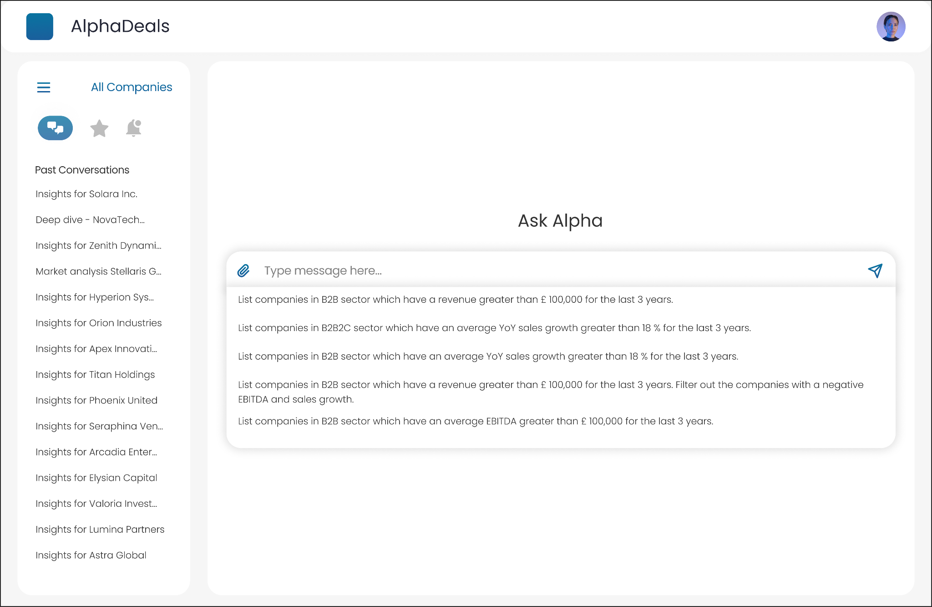

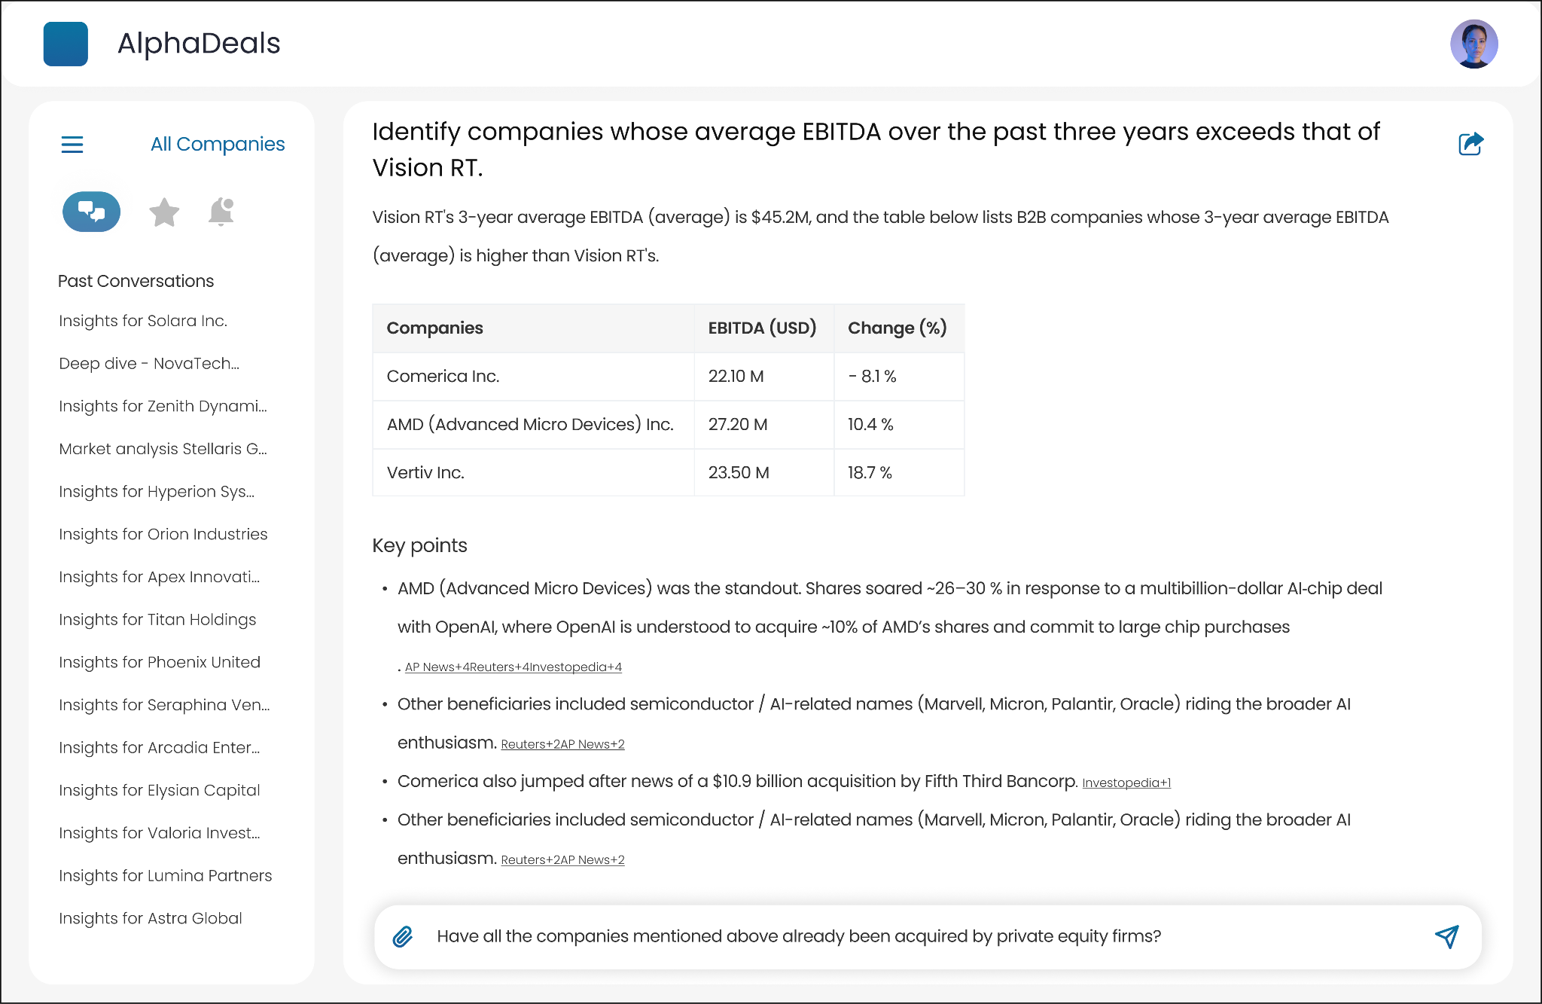
Screen - Agentic Conversation

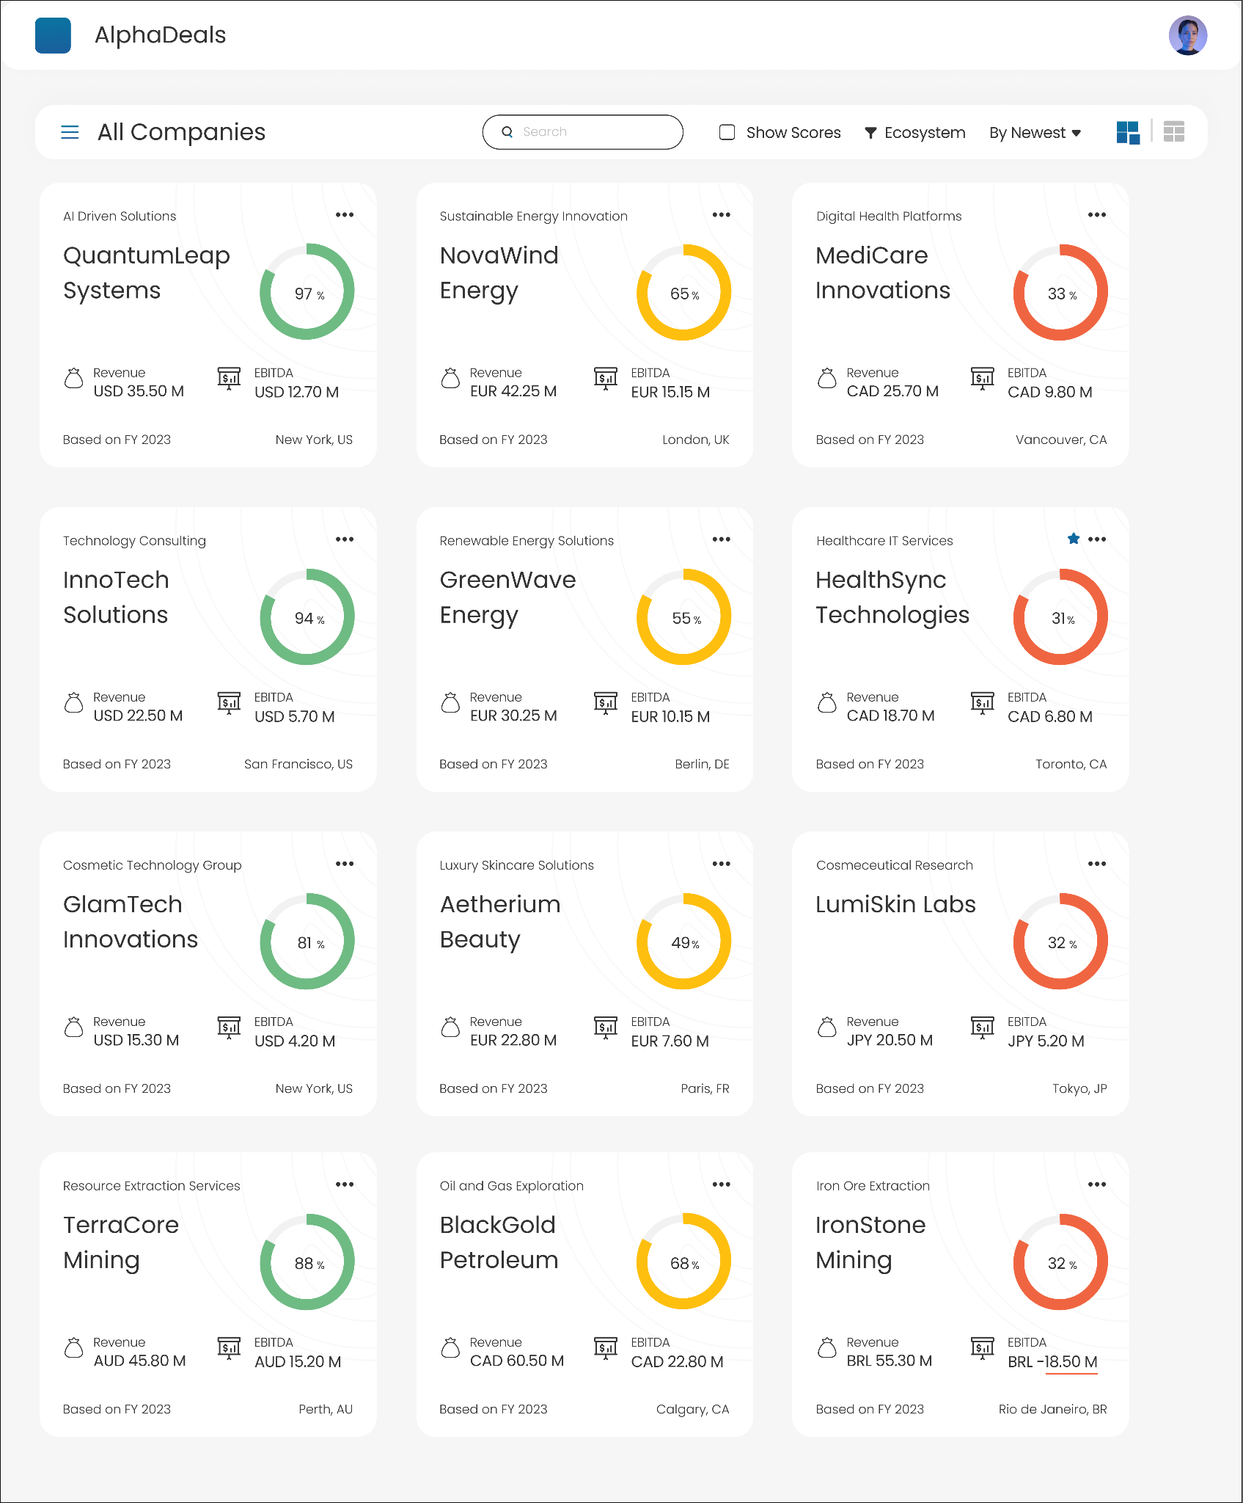Screen - Leadership Dashboard

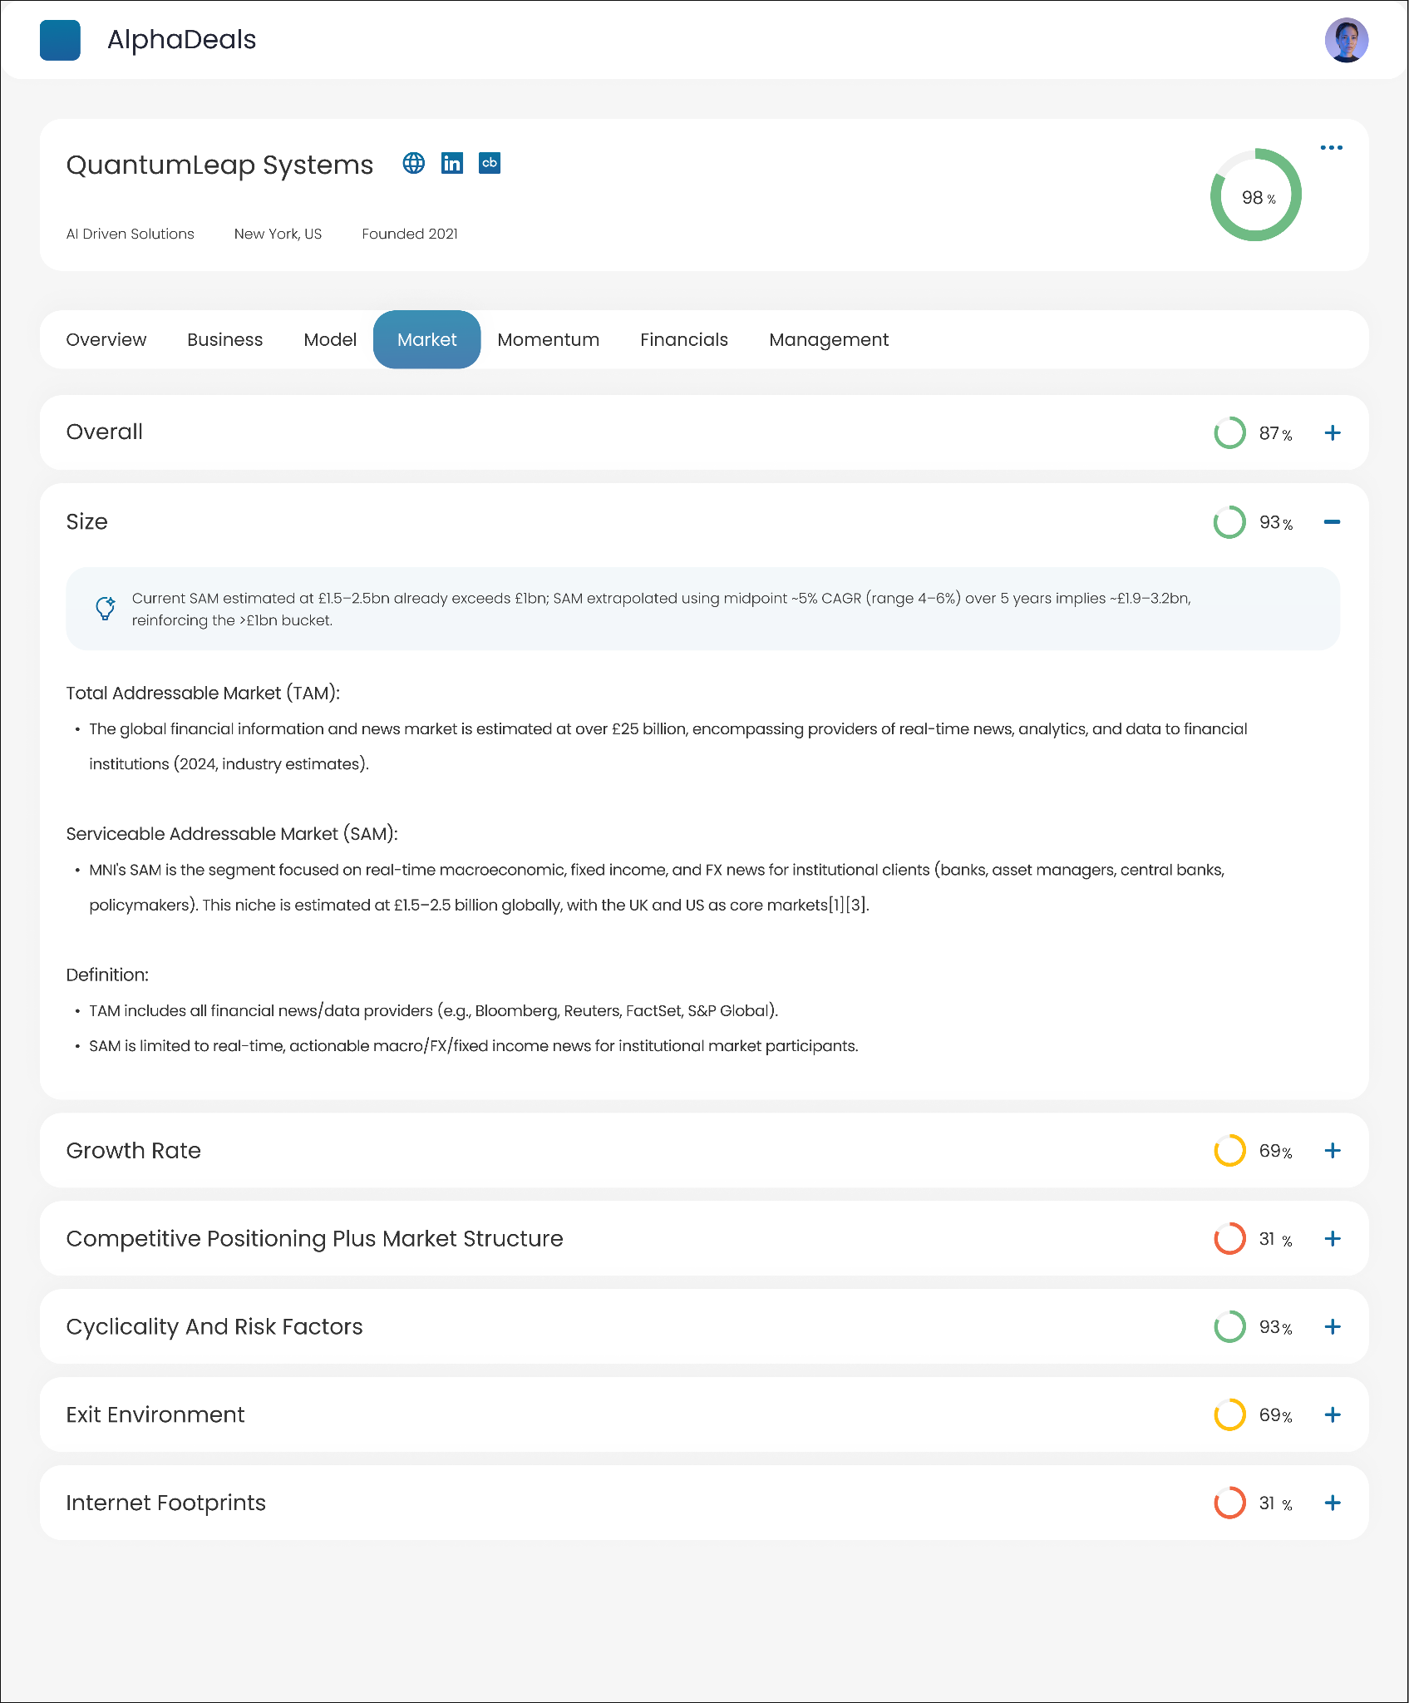Screen - Company Details Page

Case Study: From Media Specialist to Digital Aggregator
Digitizing a $300M Out-of-Home giant by replacing manual gatekeeping with a transparent, real-time AdTech ecosystem.
Role: Product Designer & Strategist | Timeline: Dec 2019 – Mar 2025
Team: 50+ Global Agile Members | Scope: End-to-End Platform Strategy & Design

Summary
Core Focus: Revenue Optimization, Workflow Automation, and Extreme Scalability

The Challenge
The traditional Out-Of-Home (OOH) advertising bidding process was bogged down by fragmented, manual, and sluggish workflows. This operational latency was actively hemorrhaging potential revenue and creating severe bottlenecks. The objective was to architect a real-time, high-frequency digital ecosystem capable of handling immense data loads without compromising user efficiency.

The Strategy & Execution
I led the architectural transition from a legacy manual model into a centralized, hyper-automated digital engine.
High-Volume Cognitive Mapping: Designed an interface capable of logically structuring and processing 50 million bids per hour. The core strategy was to shield the user from backend data chaos through a minimalist, precision-driven dashboard, allowing operators to make high-stakes financial decisions instantly.

Process Decoupling & Automation: Conducted a rigorous audit of the existing bidding lifecycle, systematically stripping away redundant touchpoints and automating repetitive tasks to create a lean, friction-less operational loop.

The Impact
Engineered a massive leap in operational efficiency, delivering a definitive 45% reduction in time and effort across the board. Most importantly, this architectural overhaul directly impacted the bottom line, functioning as a high-yield revenue engine that drove an average revenue uplift of £69,000 per client.

Digital Transformation Summary: The "Before & After"

Feature | Earlier (Conventional workflow) | Now (Transformed AdTech Biz)
Workflow | Human-led, spreadsheet-heavy. | Tech-led, dashboard-driven.
Speed to Market | 2 Weeks (Search to Dispatch). | 1 Hour (Upload to Live).
Targeting | Location-based (Address). | Audience-based (Behavior & Demographics).
Inventory Access | Limited to agency relationships. | Market-wide access (fragmented supply aggregated).
Flexibility | Rigid, long-term contracts. | Agile, one-click pause/cancel capability.
Transparency | Delayed, manual proof-of-play. | Real-time, granular analytics.

The Pre-Transformation State: The "Specialist" Bottleneck
Before the platform, the client operated as a traditional media consultancy. While profitable, the model had hit a ceiling due to inherent systemic inefficiencies:

The Fragmentation Barrier: The UK market consists of hundreds of site owners. A "Media Specialist" had to manually aggregate this supply, often juggling disparate spreadsheets, phone calls, and FTP files.

The Speed Limit: Launching a campaign took 2+ weeks. It required site scouting, rate negotiation, manual contract signing, and physical dispatch management.

The Trust Gap: The process was a "black box." Advertisers had to trust the agency's word on site selection and proof-of-play, with no real-time data to verify delivery.

The Scalability Issue: Small businesses were ignored. The cost of manual labor required to book a small campaign outweighed the profit, leaving a massive "long-tail" market untapped.

Competitor analysis
Explored Google Adwords, Facebook Ads, Adquick, Hivestack, Geotrack, PlaceExchange, Campsite (now acquired by Broadsign)

User Research, Exploration and Solutionizing

Campaign Planner’s Pain Points | Solutions 💡
Clients change their briefs frequently. It is hard to keep a track of prices and media availability. | Briefs, ad sites, rates and bookings will be saved in the SaaS platform.
It's hard to cherry-pick good frames in new areas and internationally. | Build a data platform to score ad sites and recommend them as per audiences.
It’s hard to manage large campaigns with 500 ad sites across the markets. | Ad sites to be booked and managed by the SaaS platform.
Need to continuously refer to Google Maps to visualize the ad sites. | SaaS platform to have maps and links, shareable with the clients.
It’s difficult to make amendments in the price and dates. | A dedicated amendment and cancellation workflow is created.
My clients ask for a report of every ad displayed. | Platform to generate raw data exports and UI-based reports for the clients to view.
Media sellers do not respond with rates and availability in time. | Media sellers will get notifications and reminders and will need to reply on the platform.
Media sellers don’t adhere to showing the ad on the booked sites. | Media sellers will agree to the ad sites on the platform as per the contract, it will be legally binding.

Media Sellers’s Pain Points | Solutions 💡
Clients change their briefs frequently. Need a big sales team to manage the clientele. | Media sellers need to upload their inventory on the SaaS platform and the platform will handle the sales for them.
Every unsold inventory is a permanent loss.  Want to minimize unsold media? | The SaaS platform will show a heat map of the availability and nudge the sellers to prioritize the unsold media. Media sellers can download reports and run forecasts.
It’s hard to manage a fleet of 500 - 50,000 ad sites. | SaaS platform to manage the inventory, prices and availability for them.
Clients send their ad creatives at the last moment. | Clients will ask their creative agencies to use the SaaS platform to upload and share creatives. The creative agencies will get timely notifications and reminders.

The Strategic Pivot: Building the Aggregator

To scale, we moved from a Service Economy (selling hours/expertise) to a Platform Economy (selling access/algorithms). This required three fundamental shifts in the product strategy:

Shift A: From Subjective Curation to Data Intelligence

The Specialist Way: A planner drives around the city and recommends sites based on gut feeling and experience.

The Aggregator Way: A Data Intelligence Engine grades every site in the country.

Key design interventions:

We replaced static maps with Audience Heatmaps. The interface visualizes real-time footfall and demographic data, allowing advertisers to filter by audience (e.g., "Students, Friday nights") rather than just location.

Shift B: From Buying Spots to Buying Moments

The Specialist Way: “I want a billboard on Oxford Street for a month.”

The Aggregator Way: “I want to reach party-lovers on Friday nights between 9 PM and 1 AM.”

Key design interventions:

Data Intelligence Engine: Designed an experience layer that surfaces audience insights rather than raw locations.

Moment-centric planning: The planner encourages users to think in audience segments and time windows, nudging behaviour away from location-only planning.

Shift C: From Manual Brokerage to Automated Clearing

The Specialist Way: Phone tag to negotiate rates and check availability.

The Aggregator Way: A unified Supply-Side Dashboard (SSP).

Key design interventions:

SaaS Dashboard for Media Owners: A single interface where owners input floor prices, availability, and rules once.

“Always-On Salesman” behaviour: The system automatically accepts qualifying bids that meet owner-defined rules, converting idle inventory into revenue without manual touchpoints.

The Ecosystem Architecture

We designed a comprehensive two-sided marketplace to facilitate this aggregation:

The Demand Platform (For Advertisers)

Self-Serve Campaign Planner: Users can plan complex campaigns across multiple formats (bus shelters, digital billboards, transit) in a single browser tab using a map-based interface where advertisers define audience, time, and context, and receive recommended sites ranked by “Match Score.”

Contextual Triggers: Brands can set rules to activate ads based on live conditions (e.g., “Only show my umbrella ad if it is raining”).

Creative Hub and Compliance Engine: An automated creative validation tool that checks artwork against local council laws and screen specs, preventing legal bottlenecks.

The Supply Platform (For Media Owners)

Inventory SaaS: Allows huge media owners to manage fleets of 50,000+ screens, while giving small local owners a digital storefront for the first time.

Yield Management: Visualizations of "unsold media" risks, helping owners adjust pricing dynamically to minimize wastage.

Inventory Manager: A consolidated view of both digital and static sites, enabling owners to manage availability, formats, and pricing in one place.

Revenue Forecasting: Visual heatmaps highlighting unsold or underperforming inventory and nudging owners to adjust pricing or packaging.

Business Outcomes

By evolving into a tech aggregator, the business unlocked significant value and operational efficiency:

Operational Efficiency: 45% reduction in time and effort required to plan and book campaigns.

Scale: The platform now processes 50 million bids per hour with microsecond response times.

Revenue Uplift: Average media value gain of £69,000 per client due to better targeting and yield management.

Performance: Advertisers engaged via the platform saw a 3x uplift in purchase intent and 70% audience uplift compared to traditional bookings.

Design Artifacts White labeled (Bound by NDA)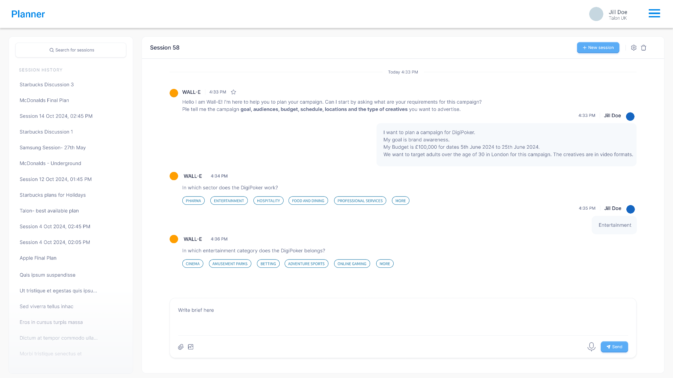
Screen - Capturing the campaign brief
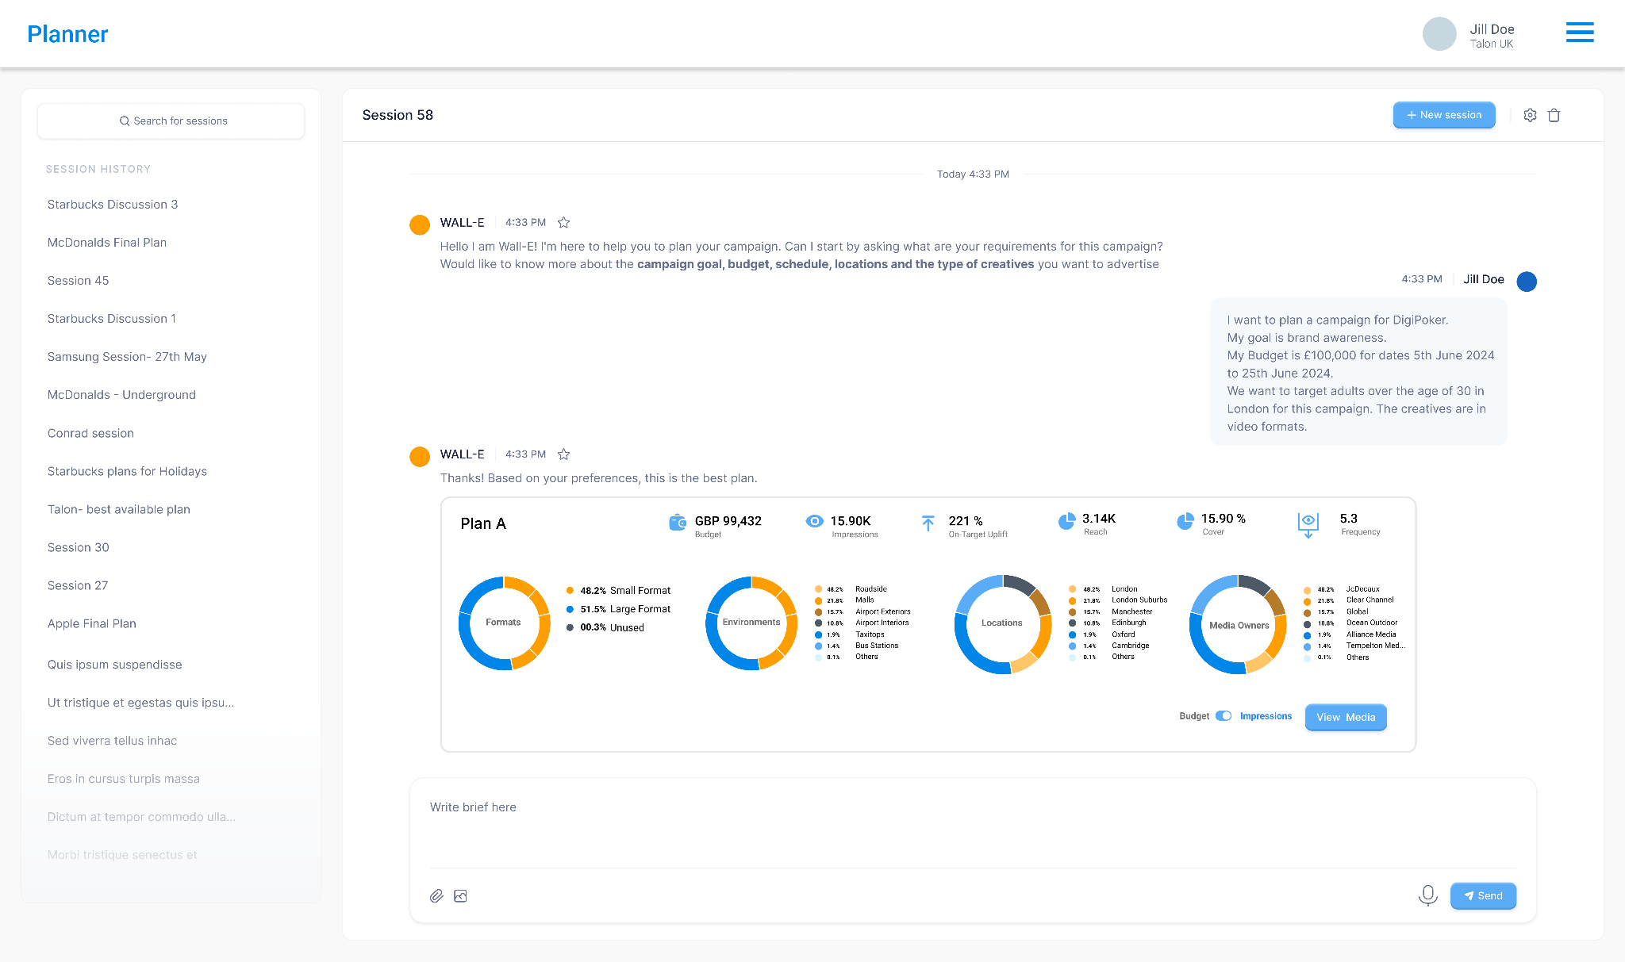
Screen - A campaign plan suggested by Machine Learning
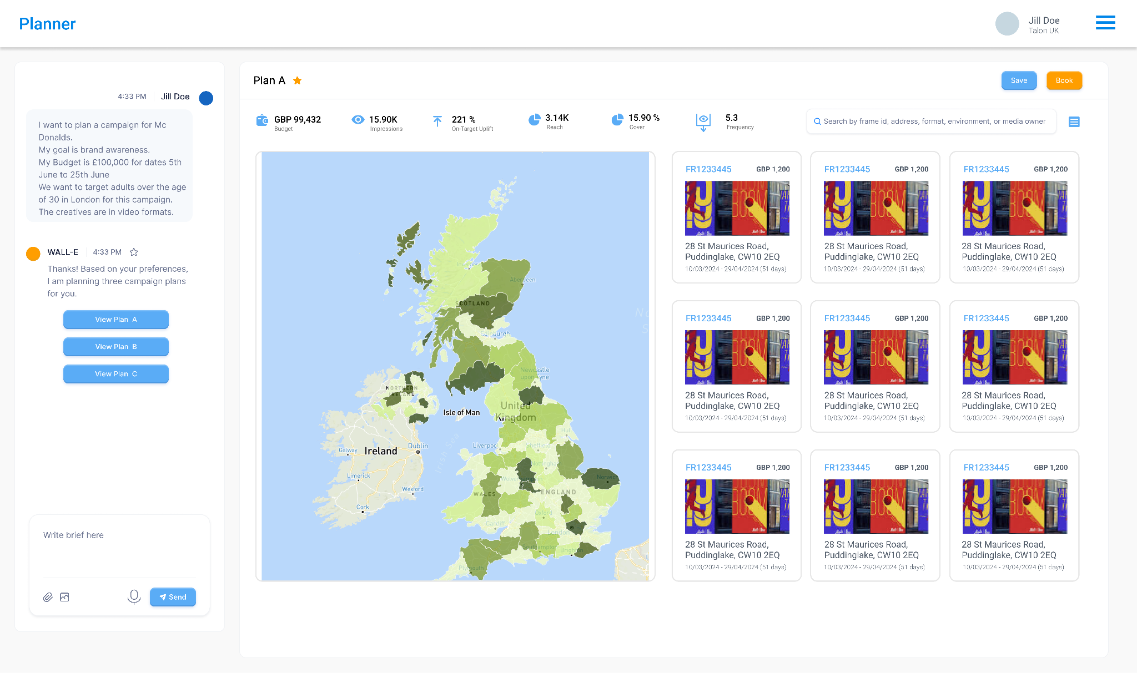
Screen - Deep dive into the media plan
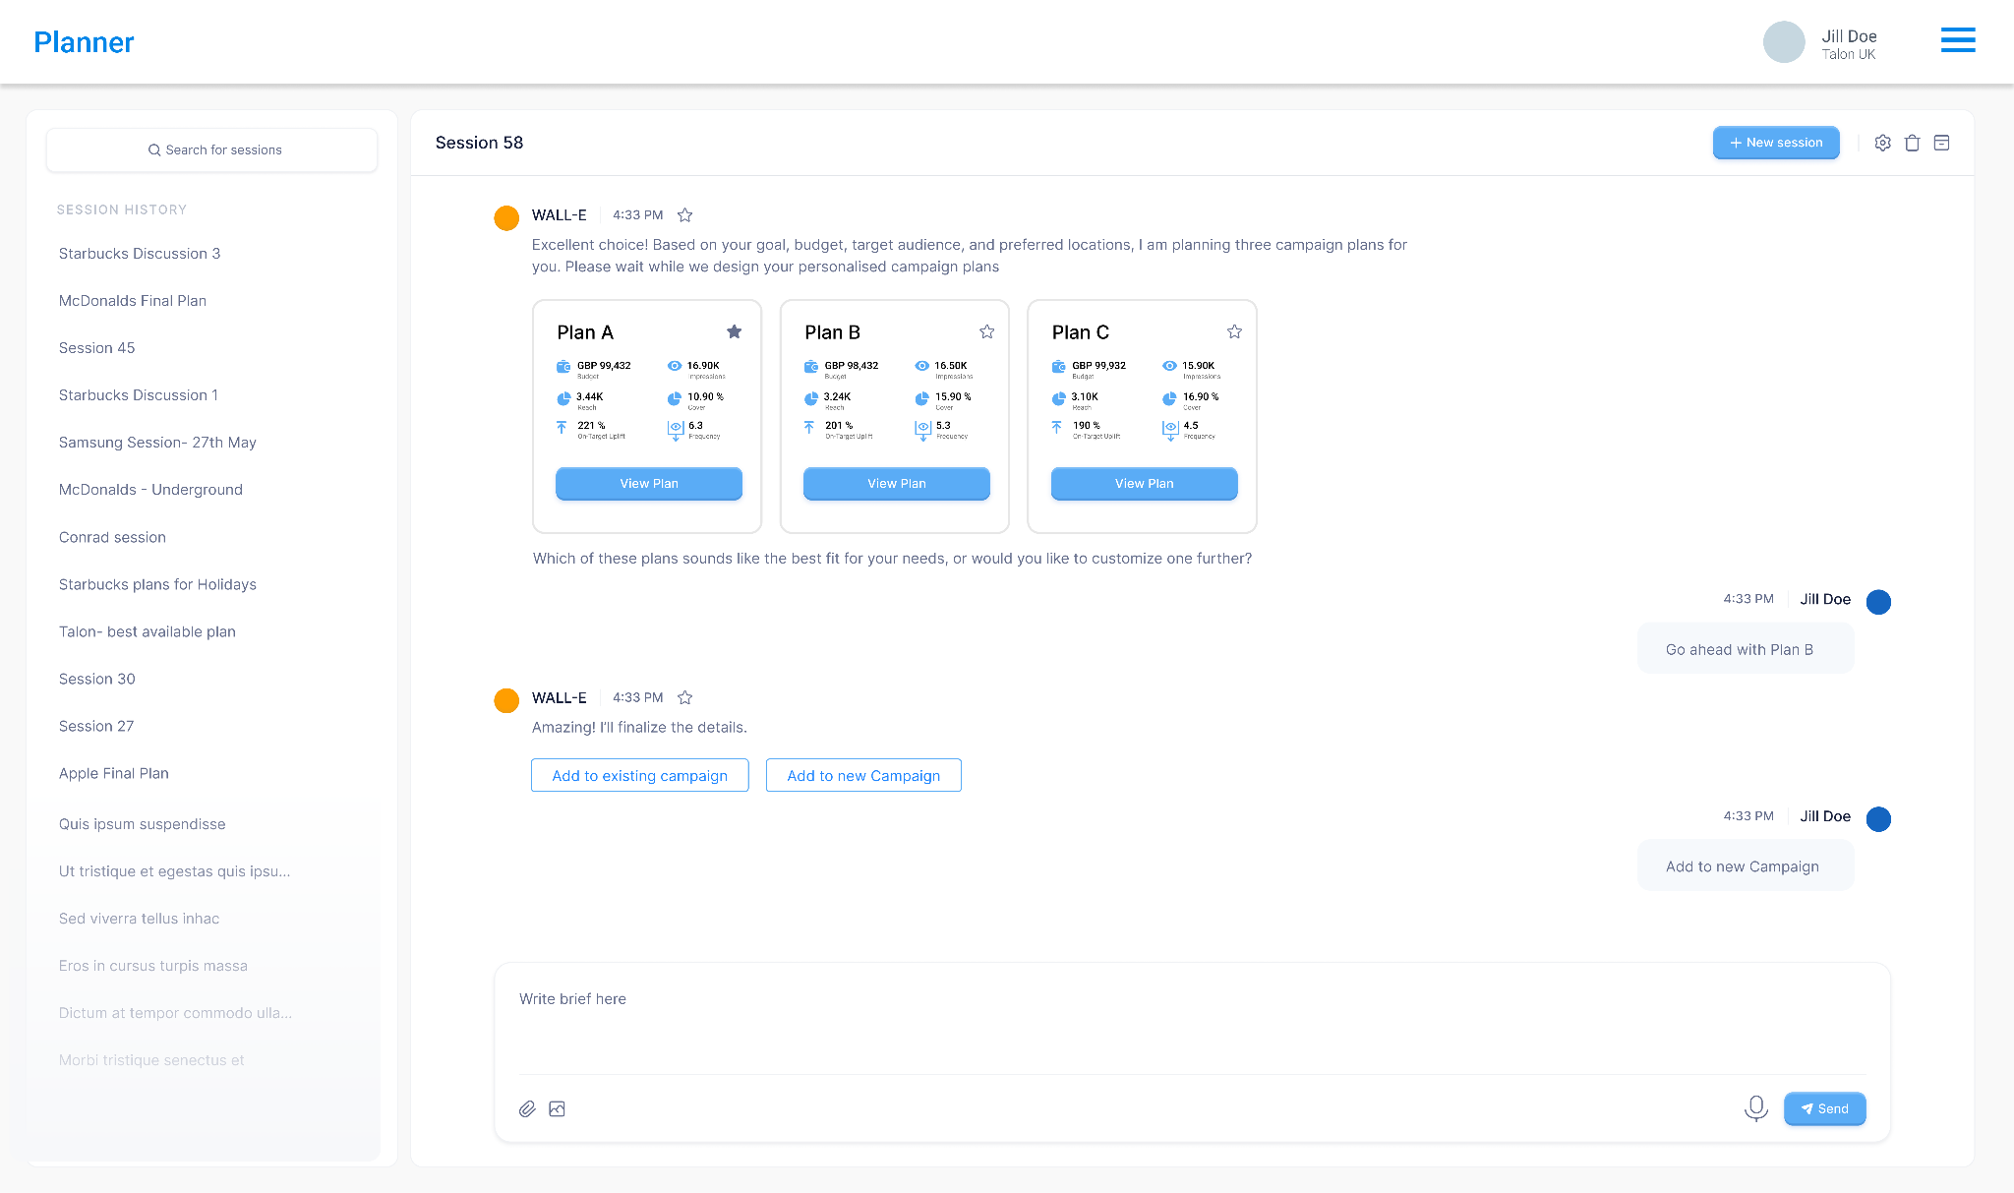
Screen - Suggesting and comparing multiple campaign plans

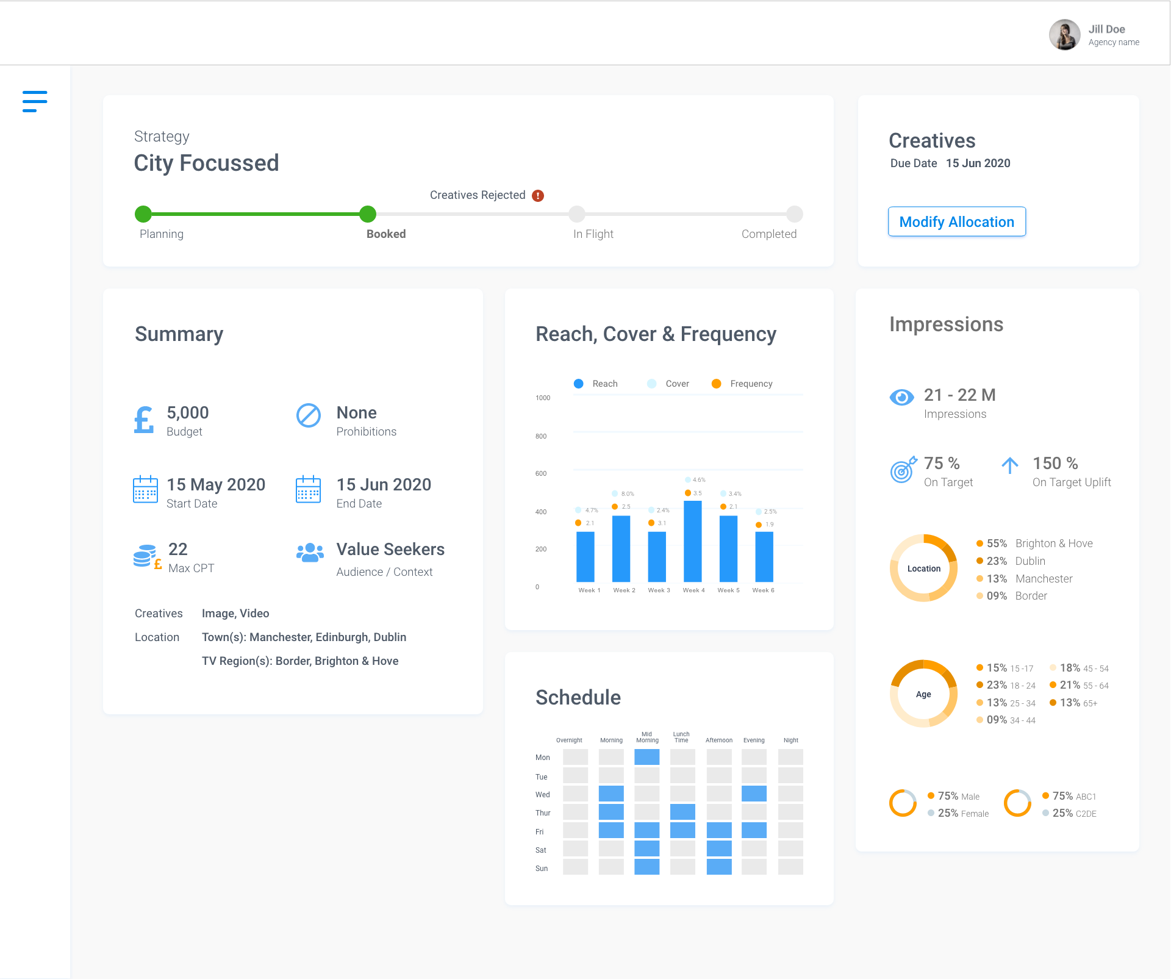
Screen - Campaign Planning and Booking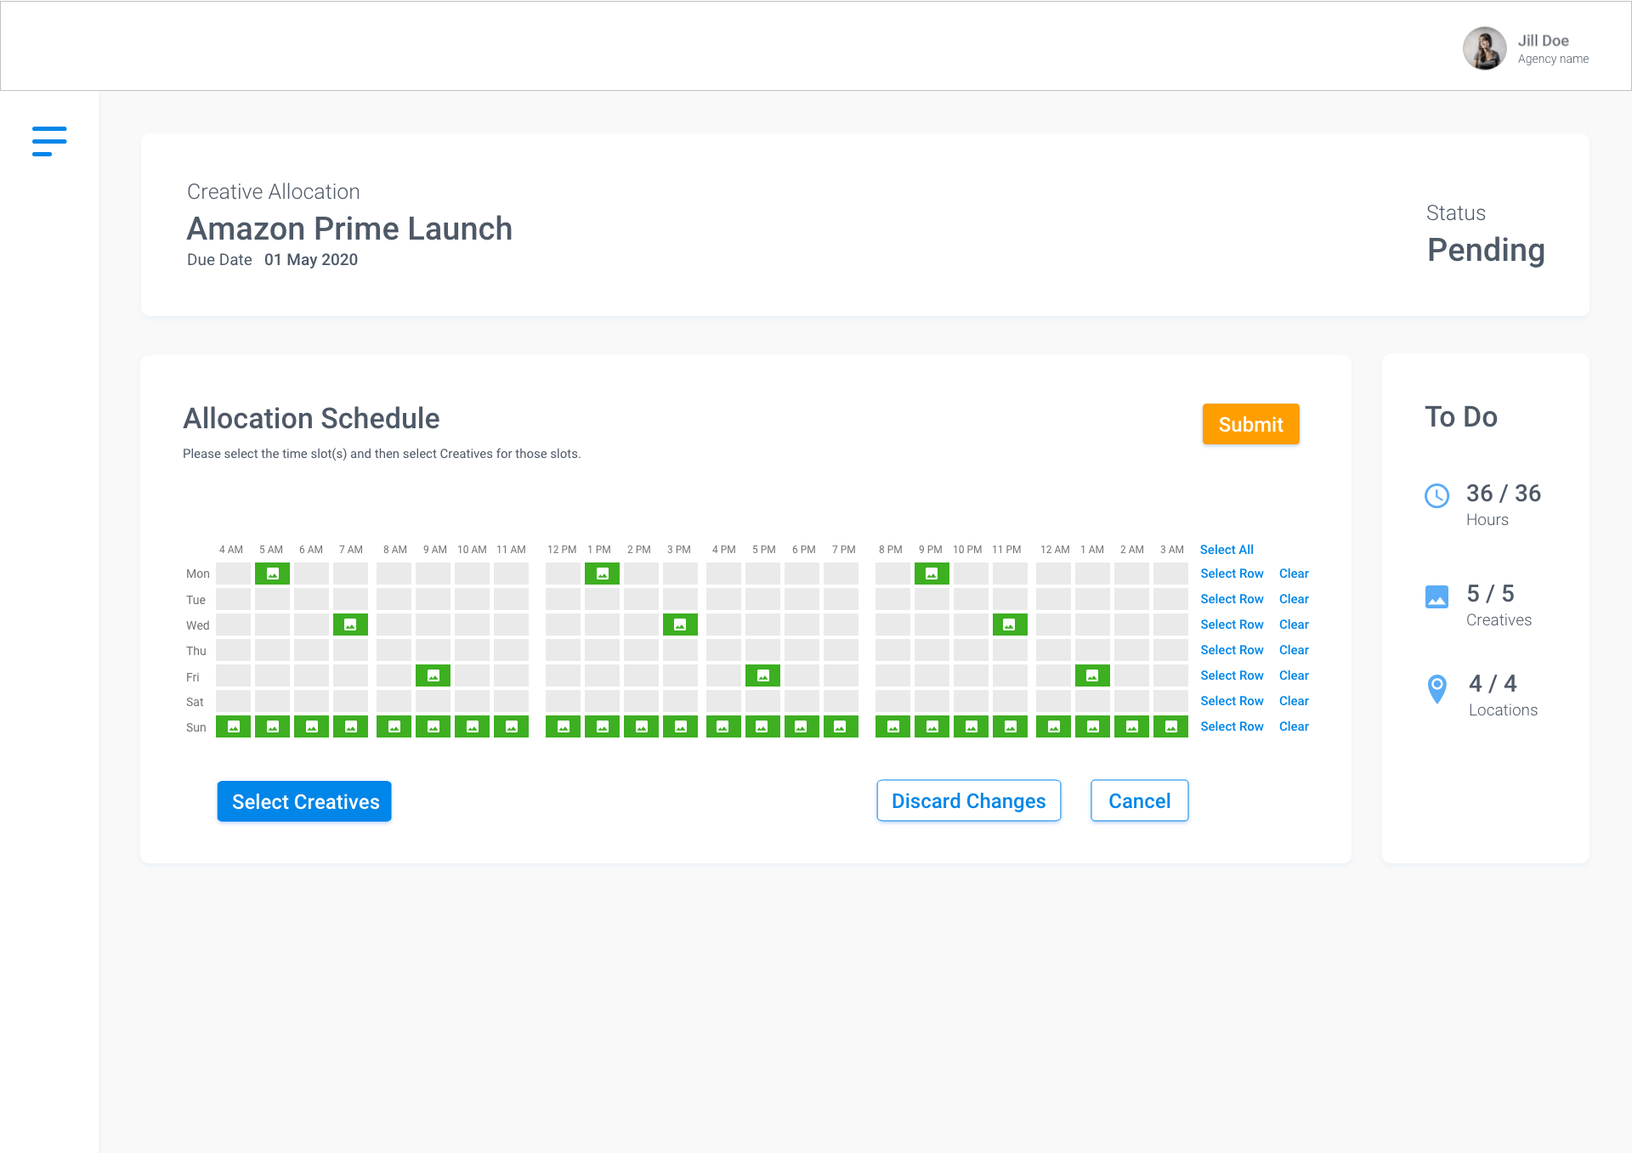
Screen - Scheduling the display of Ads

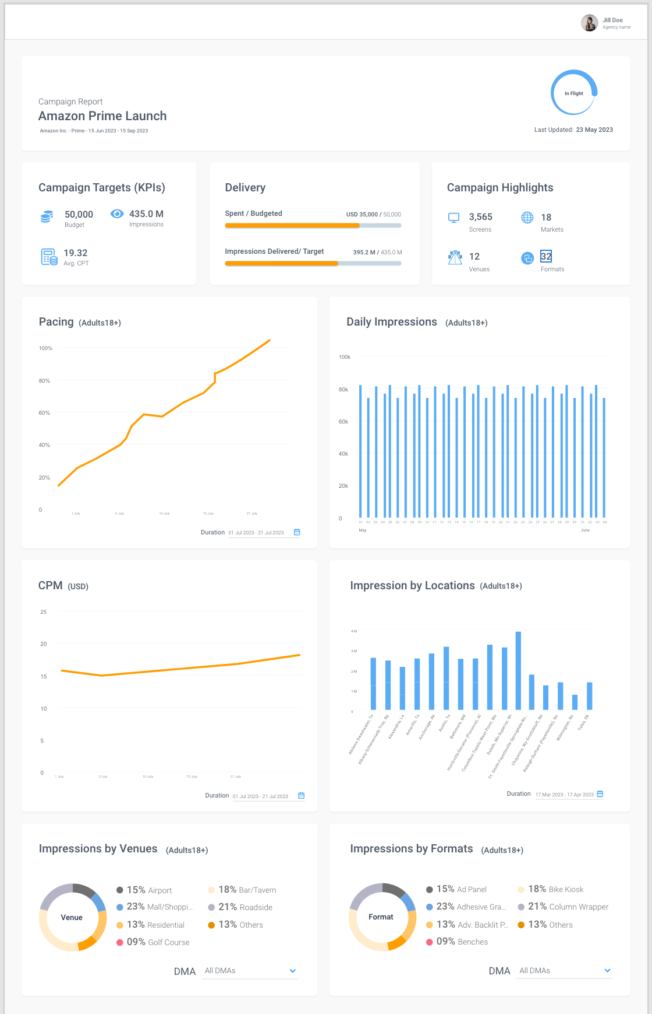

Screen - Campaign Tracking & Reporting

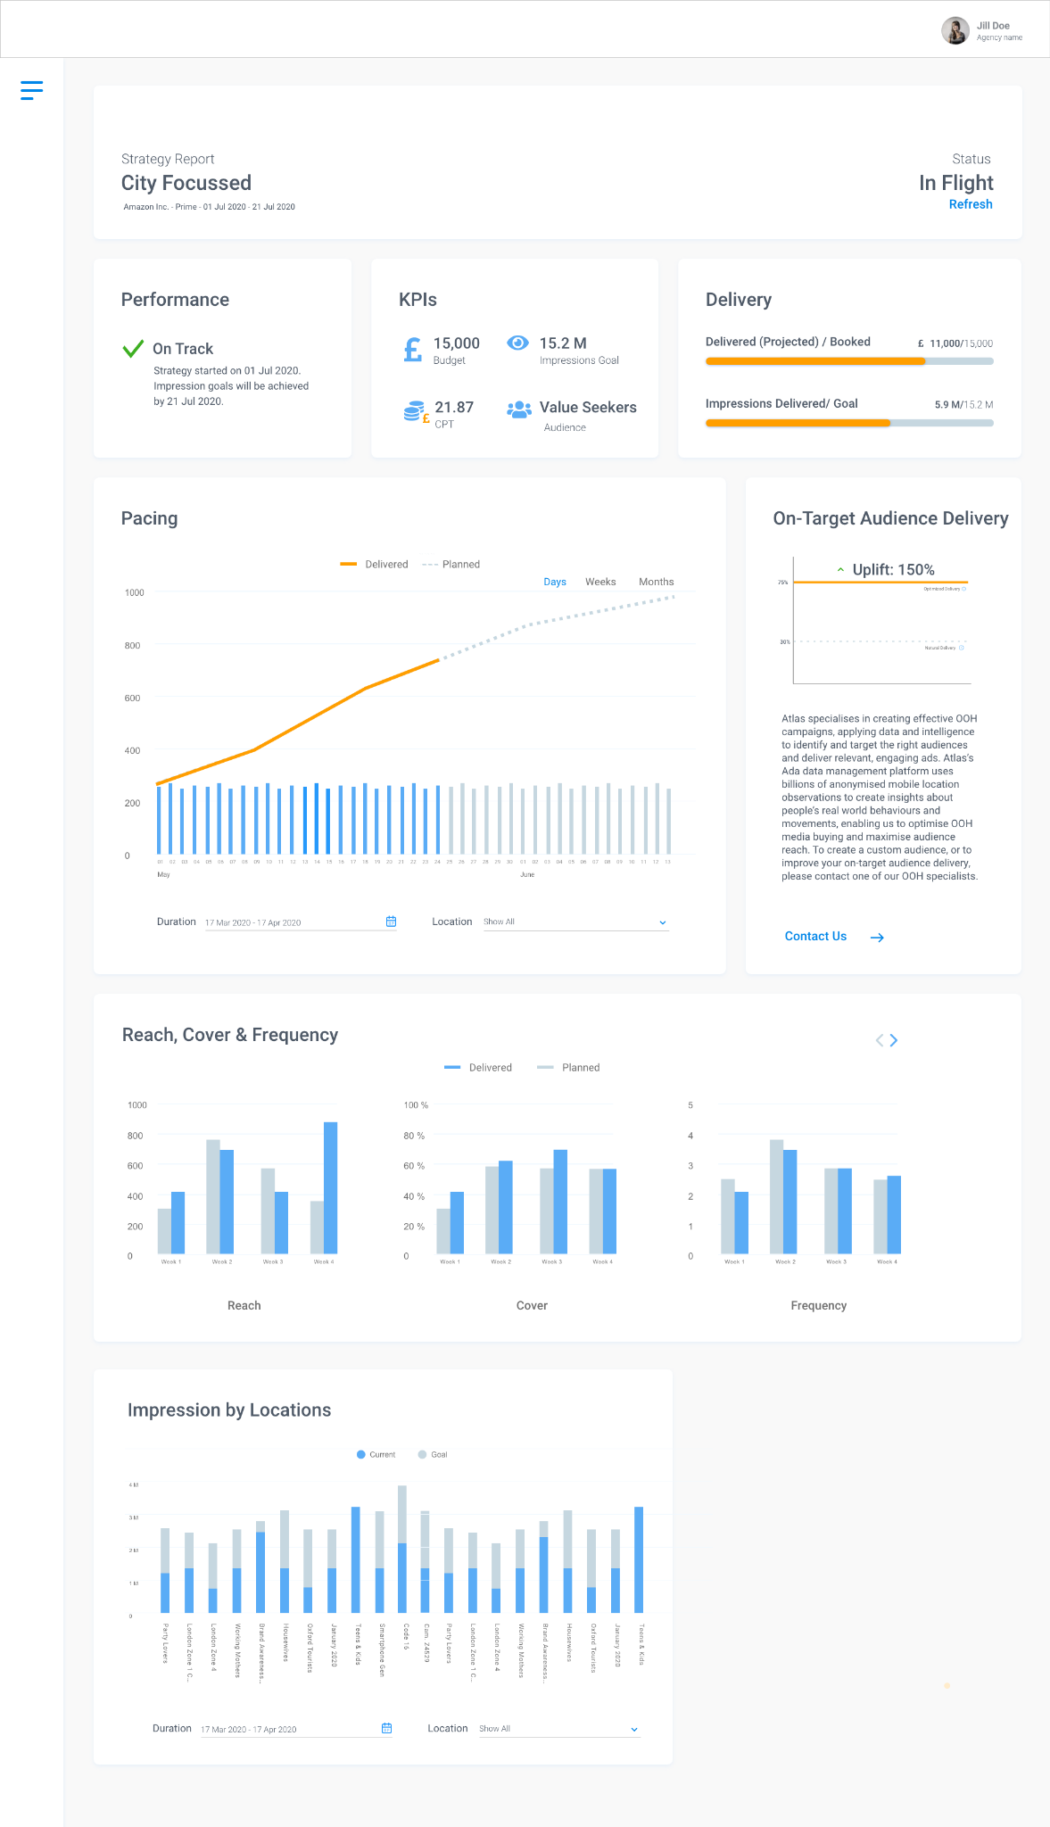
Screen - Bidding Tracking & Reporting

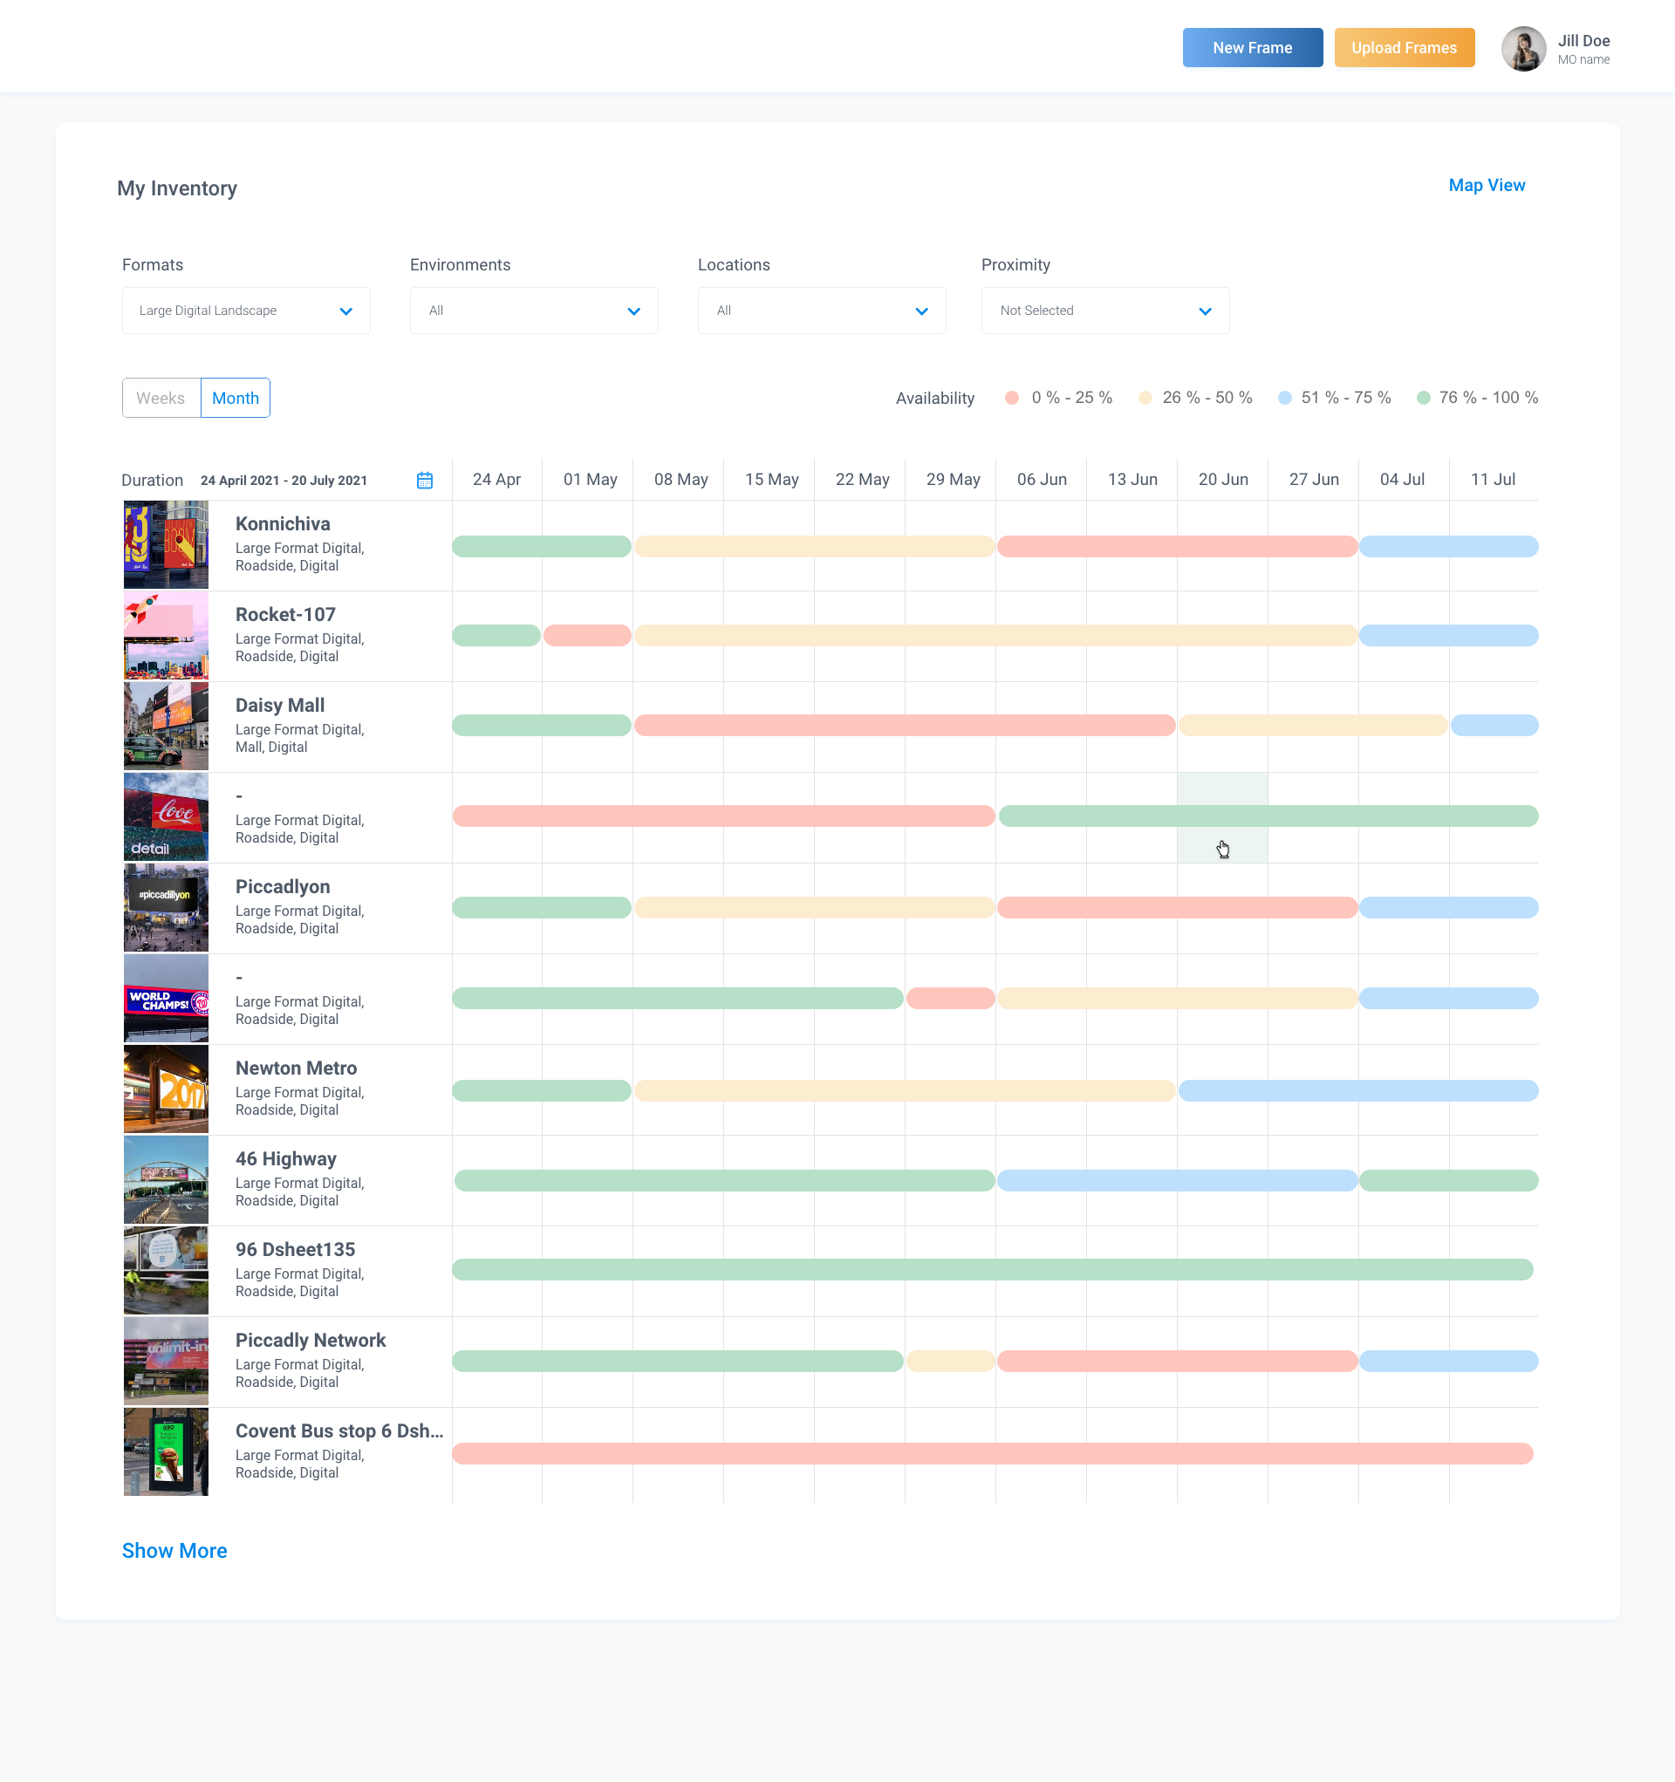
Screen - Media Seller’s Inventory Management App

Reclaiming the Commute: PlanIt Prioritized Comfort Over Speed
A Case Study in Human-Centric Travel Design
Role: Designer & Strategist | Timeline: Jul - Dec 2021 | Team: Remote / Distributed Agile
https://planitnow.co.uk (Deprecated)

Executive Summary
Core Focus: Behavioral Psychology, Cognitive Load Reduction, and Affective Design

The Challenge
Public transit navigation is inherently high-stress and unpredictable. Existing transit applications provided basic utility but entirely ignored the psychological friction and cognitive load experienced by daily commuters. This emotional disconnect often leads to high user churn and frustration, especially during transit delays or cancellations.

The Strategy & Execution
Instead of building another purely transactional map, I engineered an "Affective Design" framework. The goal was to build a resilient user-product bond by mitigating travel anxiety through strategic behavioral interventions.

Behavioral Nudges via Persona Design: I introduced a dynamic mascot—not as a decorative element, but as a strategic behavioral nudge. This persona acts as a psychological anchor, providing real-time, empathetic feedback that builds "systematic trust" and guides users calmly through high-tension scenarios (e.g., missed trains).

Cognitive Load Reduction: I overhauled the visual architecture, utilizing progressive disclosure and a strategically warm color palette. This lowered visual clutter and reduced the mental effort required for users to make split-second navigational decisions under pressure.

The Impact
Successfully bridged the gap between cold machine logic and human psychology. By treating commuter anxiety as a design metric, the behavioral interventions transformed a stressful utility into a trusted daily companion, effectively lowering cognitive friction and driving sustained Daily Active Engagement (DAU).

Setting the stage: a hostile daily ritual

For millions of commuters in London and across the UK, the journey to work is not a neutral routine; it is a daily emotional stress test. The commute is measured not only in minutes and miles, but in elevated heart rates, tense shoulders, and the dread of being squeezed into overcrowded carriages.
By 2021, the transit app landscape mirrored this cold logic. Tools like TfL Go and similar journey planners optimized relentlessly for speed, answering “What is the fastest route?” with mathematical precision, while ignoring the more human plea: “Will I be able to breathe when I get on this train?” In this environment, users—especially the anxious, the elderly, expecting mothers, or anyone carrying luggage—were treated as variables in an algorithm, not as humans with limits.

When data meets a deeper question

PlanIt entered this space with a powerful technical capability: near real-time footfall data from the London Underground and National Rail that could predict quieter times to travel. On paper, this solved a clear problem. In reality, something crucial was missing: trust, comfort, and emotional safety.
The real challenge was never about whether the model could predict crowd levels. It was psychological. How could an app persuade an anxious commuter to choose a slightly slower journey in exchange for a calmer, more breathable experience? How could a grid of numbers convince a grandmother visiting her family that she could travel without fear of being jostled or overwhelmed?
This is where design stepped forward as the central character. The product’s goal crystallized into a single line: transform a utilitarian data set into a supportive travel companion. Design was no longer a coat of paint; it became the bridge between cold predictions and human reassurance.

Design changes the brief: from “user” to “human”

The first decision design made was to reframe who this product was for. Instead of speaking to a generic “user,” the team deliberately focused on the people most affected by crowd anxiety:

Elderly travelers visiting loved ones.

Expecting mothers instructed by doctors to avoid stress.

People with mobility needs, strollers, or heavy luggage.

Anyone still wary of physical proximity after recent public health crises.

For these people, traditional transit app interfaces—stacked data, aggressive blues, tight grids—did not feel empowering; they felt demanding, shouting departure times and platform changes without mercy. The design initiative recognized that this audience did not need another “efficient tool”; they needed a calm presence in their pocket. Design redefined its role: it would act almost like a sedative, visually and verbally slowing the experience down so that decisions felt easier, not more pressured.

Visual identity: the “anti-utility” stance

With that reframing, design made its next bold move: a visual identity that rejected the common “utility app” aesthetic. Competitors leaned heavily on “tech blue,” muted greys, and sharp edges—the visual language of corporate dashboards. PlanIt needed to feel like the opposite: gentle, warm, and unthreatening.

Design introduced a palette rooted in warm primaries and soft, complementary accents. These colors were chosen not merely to look “nice” but to signal psychological safety, especially for users who felt alienated by clinical, high-tech interfaces. Warm tones turned the app into a place you arrive at, not a system that interrogates you.

Primary | Primary | Accent | Accent | Base

Typography played an equally strategic role. The team chose Prompt, a modern Google font that paired clear readability with rounded, friendly forms. Prompt’s character helped PlanIt feel approachable instead of institutional. For older users or those with visual strain, this was critical: the type needed to be highly legible without sliding into the aesthetic of hospital signage. Typography here was not ornament; it was an accessibility and empathy decision.

Voice & tone: from dry metrics to a British companion

Once visual design had softened the surface, language needed to carry that warmth into every interaction. Raw phrases like “Footfall density: High” or “Traffic: Severe” reinforced anxiety rather than relieving it. Design intervened by crafting a colloquial, distinctly British voice that treated commuters like friends, not endpoints.

Instead of “High Traffic,” PlanIt might say: “Quietness: 3/10 – Very busy. Imagine Platform 9¾ on the first day at Hogwarts.”

Instead of curt commands, copy encouraged slower, kinder choices: “A quieter time is coming up—bring your book, a seat should be waiting for you.”

These choices were deliberate. They turned abstract metrics into relatable mental images and reoriented the app away from pure instruction and toward companionship. Design understood that tone could either amplify tension or gently diffuse it; every sentence was written to do the latter.

The mascot: design invents an emotional anchor

The turning point in the narrative came when design created PlanIt’s mascot: a small, expressive train character that became the emotional anchor of the experience.

The PlanIt Train emerged as a friendly guide through the journey. It greeted users warmly, celebrated clear routes, and visibly “felt bad” when things went wrong. Error states, traditionally the most frustrating part of any interface, became a playground for emotional design



A surprising outcome surfaced during testing and usage: some people intentionally triggered broken flows just to see the sad mascot animation. What had once been a friction point turned into a moment of delight. Design had taken an unavoidable negative—technical failure—and alchemized it into a micro-experience of empathy and playfulness.

Interaction & information design: clarity in the noise

Even while design was busy humanizing the product, it never lost sight of the need for clarity. Underneath the charm, commuters needed sharp, actionable guidance. The challenge: distill complex crowd data into something instantly understandable without cognitive overload.

Design landed on the “Quietness” score—a single 1–10 scale that translated complex data streams into a clear, human-readable signal. Users could glance at a route and grasp, within seconds, whether this was a tight squeeze or a comfortable ride. This score was further reinforced through color:

Greens indicated comfortably quiet times.

Ambers suggested moderate crowding.

Reds warned of busy or very busy windows.

However, unlike harsh, neon indicators, the palette softened these colors to align with the brand’s calming personality. This preserved semantic clarity while avoiding the panic that pure red might trigger.

Accessibility was treated as a first-class constraint, not an afterthought. Large touch targets made it simple for users with reduced dexterity to navigate key actions. Contrast ratios were tuned to stay high enough for visually impaired users, even while retaining the warm aesthetic. The result: an interface that felt gentle but performed with the precision of a tool built for everyone from 18-year-old students to 80-year-old grandparents.

Outcomes: what design actually changed

The impact of design’s leadership was visible at three levels: usability, emotion, and business.

Usability: Customer service recorded zero usability-related complaints across the early launch window. Users of various ages navigated the app without tutorials, indicating that interaction patterns and visual hierarchy were intuitive and self-explanatory.

Emotional engagement: People returned not just for predictions about quieter trains but for personality—witty copy, comforting language, and the expressive PlanIt Train mascot. Emotional features, particularly the mascot and tone of voice, became key retention drivers rather than “nice-to-haves.”

Business performance: By leaning into the “comfort niche,” PlanIt hit its traction goals: 1,000 unique visitors and 250 active users per month, forming a loyal base that larger, speed-optimized apps had effectively ignored. The product did not attempt to out-Google Google; instead, it owned a distinct, emotionally resonant territory.

Mobile Artifacts

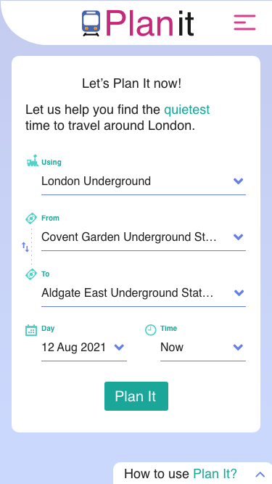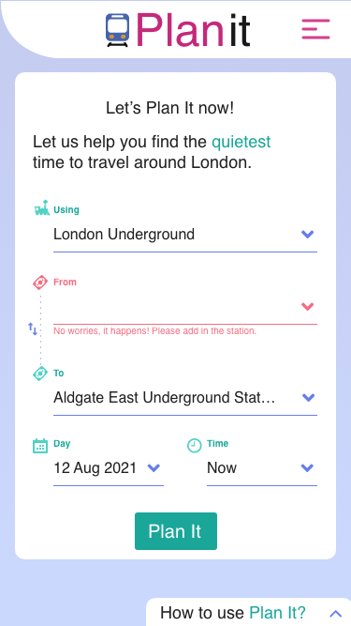

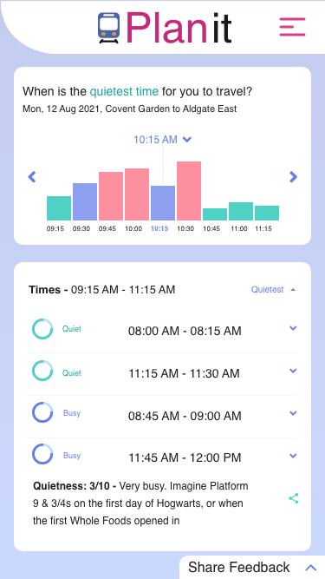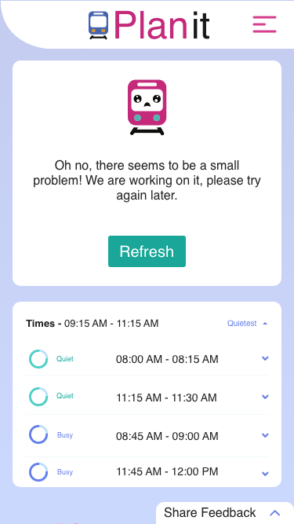

Desktop Artifacts

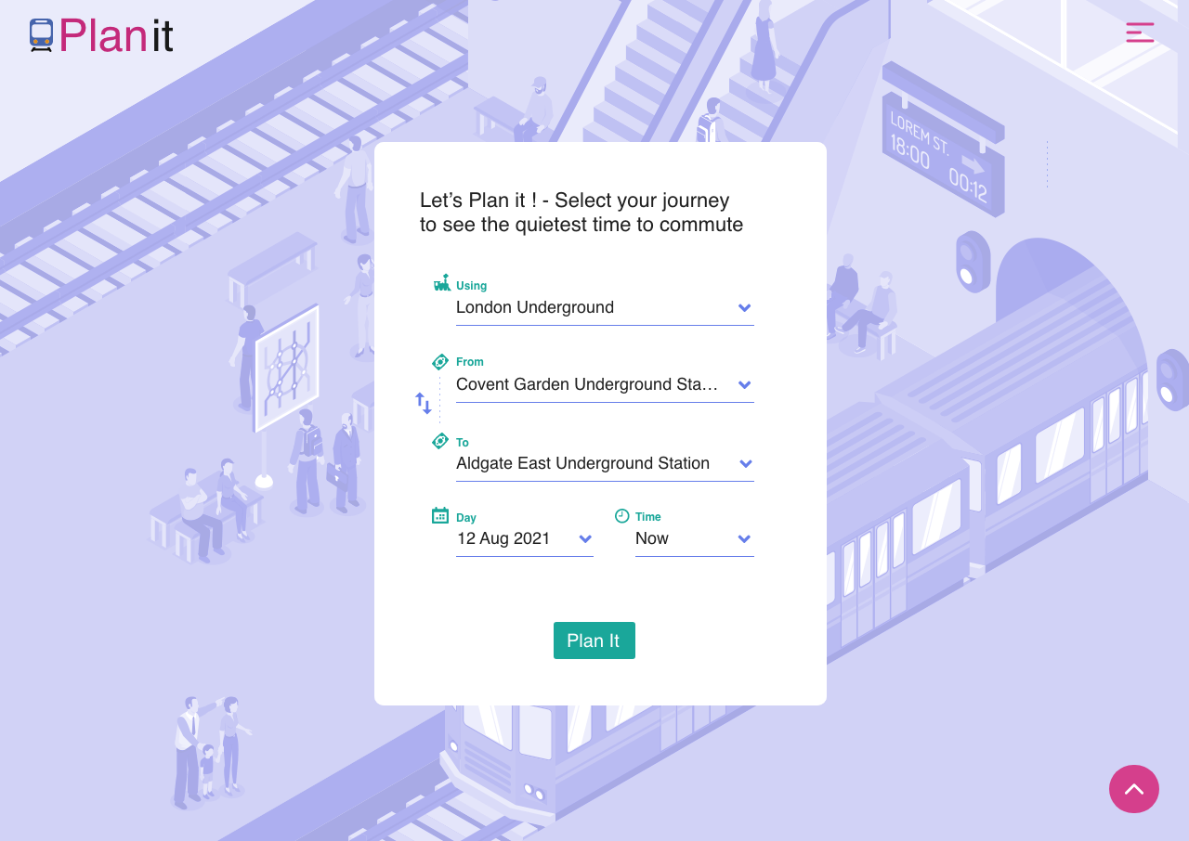

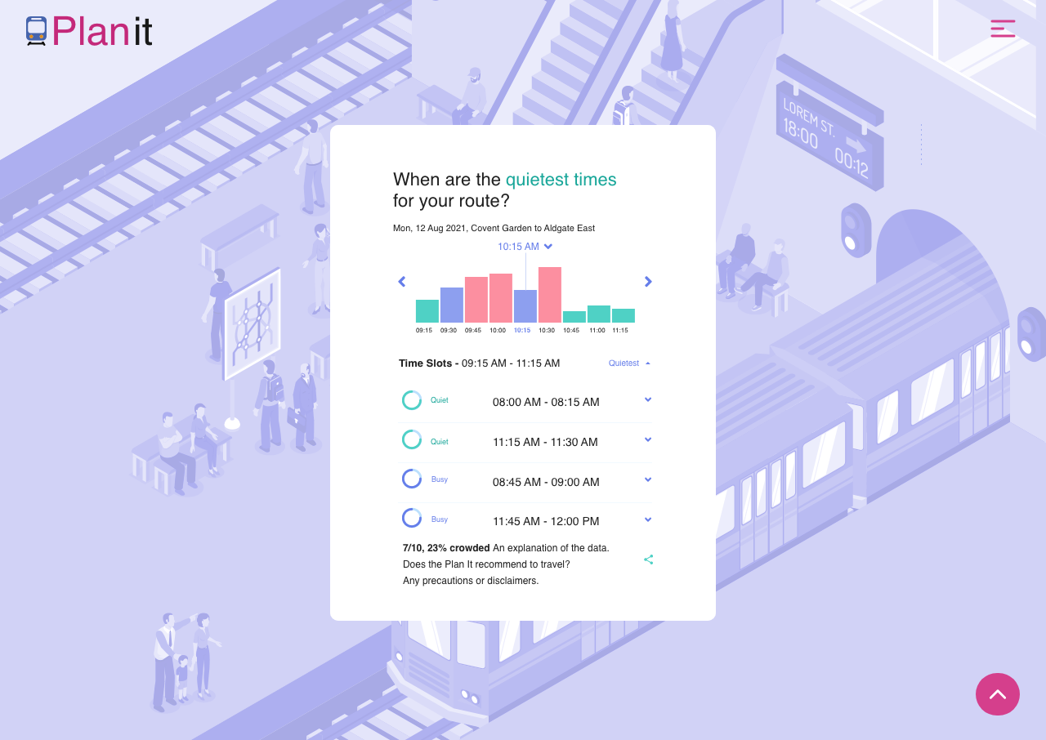

Case Study: EdTech platform for professionals
Role: Designer and Strategist (Mar 2014 – Dec 2019), collaborating in-office with a distributed, cross-functional agile team, supporting multiple concurrent product streams.

Summary
https://learningconnector.ptc.com/
This narrative traces the evolution of a diverse set of e-learning products into a cohesive EdTech platform serving 350,000 professional learners. PTC, headquartered in Boston and recognized as a frontrunner in manufacturing technology, operates PTC University—an educational division committed to advancing product adoption, customer education, and retention. Among its prestigious clientele are organizations such as NASA, Toyota, GE, Boeing, Airbus, Apple, Samsung, Vertu, Garmin, Lockheed Martin, Volvo, Caterpillar, and Lufthansa.
Joining as the inaugural design specialist at PTC University India, I helped scale the UX and UI development team over six years into a distributed, multi-disciplinary Customer Experience (CX) team.

Transformation Highlights

Unified the Platform: Enhanced customer experience by merging five standalone learning products into a single, integrated EdTech platform.

Business Model Evolution: Transitioned from perpetual licensing to annual subscription models, establishing recurring revenue streams and significantly raising turnover.

Introduced Use Case–Driven Learning: Refined the learning content to focus on real-world use cases, ensuring materials are practical, relevant, and directly applicable to learners’ professional challenges.

Micro learning: On-the-job learning, tutorials, and community forums.

Macro learning: Comprehensive courses and structured training programs.

Innovative Learning Solutions: Rolled out new offerings to support MOOCs, focusing on advanced technologies like IoT and AR/VR.

Sustainability Initiative: Led the move from printed to digital guidebooks, reducing costs and saving $1M annually in production and logistics.

Mobile & Web Optimization: Made the platform fully responsive and expanded access by enabling web accessibility.

Global Reach: Increased language support from eight to eleven locales, broadening the platform’s reach.

Enhanced Digital Presence: Boosted the platform’s online visibility through SEO and dedicated marketing strategies.

The Challenge
Prior to the initiative, the company faced several critical roadblocks that hindered growth and user satisfaction:

Fragmented User Experience: Learners had to navigate across five standalone products, creating a disjointed and frustrating customer journey.

Stagnant Revenue Model: Relying on one-off perpetual licensing limited the ability to forecast revenue and fund continuous platform improvements.

High Operational Costs: The production and logistics of physical printed guidebooks were environmentally unsustainable and financially draining.

Outdated Pedagogy: Content was highly theoretical and lacked the immediate, on-the-job applicability demanded by modern professionals.

Limited Reach: The platform lacked responsiveness across devices, was inaccessible to certain user demographics, and was restricted to eight local languages.

The Strategy & Execution
1. Platform Unification & Experience Design
To eliminate user friction, the product design team audited and merged the five standalone learning products into a single, cohesive EdTech platform.

Responsive & Accessible: The UI/UX was entirely rebuilt to be fully responsive, ensuring a seamless experience across desktop, tablet, and mobile. Crucially, the platform was upgraded to meet modern web accessibility standards, democratizing access for all users.

Centralized Hub: A unified dashboard was created, giving users a single point of entry to track their progress, access resources, and manage their subscriptions.

2. Pedagogy Pivot: Use Case-Driven Learning
The content strategy was overhauled to focus on practical, real-world utility. Instead of abstract theory, materials were redesigned around specific professional challenges. This was delivered through a new dual-format learning architecture:

Micro-learning: Designed for learning in the flow of work. This included short, on-the-job tutorials, quick-reference guides, and peer-to-peer community forums for rapid problem-solving.

Macro-learning: Deep-dive, comprehensive courses and structured training programs designed for foundational upskilling and certification.

 | Microlearning (Unstructured) | Macrolearning (Structured)
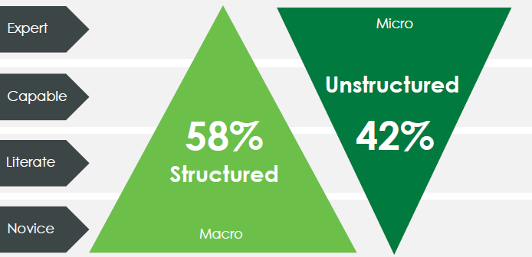 | I need to figure it out now. | I want to invest in skills.
 | Video, text, article, support call | Courses, classes, MOOCs, programs
 | 2-20 mins of commitment  Topic or problem based  Search by keywords / query  Medium: Web or in-product | 2 hr+ time commitment  Find by recommendation  Medium: Lesson based  Courses and workshops
John Bersin, Deloitte. Above tables adapted from Bersin’s work.

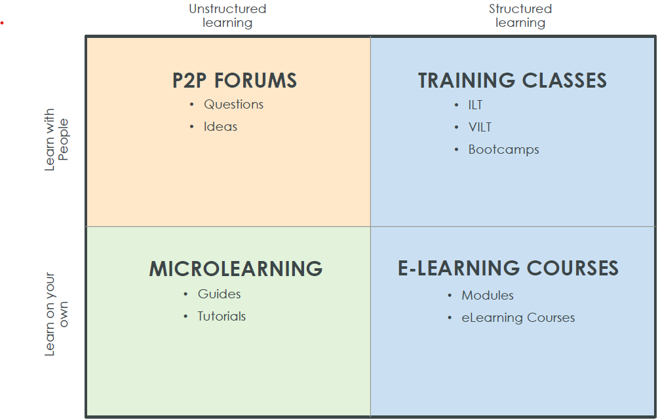 | 70% of employees prefer to learn at work
 | 60% of employees prefer to learn at their own pace
 | 50% of employees prefer to learn at the point of need
 | A majority of employees don’t have time to commute to attend training and workshops
 | Most of the employees want to get immediate results from training.
As per LinkedIn study.

3. Business Model Evolution & Sustainability
The design and product teams worked closely with business stakeholders to transition the platform from perpetual licensing to an annual subscription (SaaS) model.

Value Delivery: By constantly updating micro and macro learning content, the subscription model was justified through continuous value delivery, establishing a predictable, recurring revenue stream.

Digital Transformation: The team spearheaded a sustainability initiative to eliminate printed guidebooks. By designing interactive, easily updatable digital guidebooks within the platform, the company vastly reduced its carbon footprint.

4. Technological Innovation
To position the platform as a market leader, the product team rolled out advanced offerings to support Massive Open Online Courses (MOOCs). The curriculum was expanded to include cutting-edge tech verticals, specifically introducing immersive learning experiences in IoT (Internet of Things) and AR/VR (Augmented and Virtual Reality).

5. Global Expansion & Market Presence
To capitalize on the new, scalable architecture, the platform's reach was aggressively expanded:

Localization: Language support was scaled from eight to eleven locales, opening up new international markets.

Discoverability: The new unified web architecture was optimized for SEO, supported by dedicated digital marketing strategies to boost organic visibility and drive top-of-funnel acquisition.

The Impact and Results
The product design initiative fundamentally altered the trajectory of the company, balancing user-centric design with aggressive business goals:

Financial Growth: The shift to an annual subscription model successfully established strong recurring revenue streams, significantly raising overall company turnover.

Massive Cost Savings: The sustainability initiative to digitize guidebooks completely eliminated print production and shipping costs, saving the company $1M annually.

Enhanced User Engagement: The introduction of use-case-driven micro and macro learning formats led to higher completion rates and daily active usage, as professionals could immediately apply their learning on the job.

Broader Market Penetration: By making the platform fully responsive, web-accessible, and available in eleven languages, the Total Addressable Market (TAM) was vastly expanded.

Future-Proofed Technology: Integrating AR/VR and IoT into a unified MOOC-capable ecosystem established the brand as an innovative leader in the EdTech space.

Decreased Customer Support Volume: The intuitive, centralized dashboard, combined with easily searchable digital guidebooks and peer-supported community forums, empowered users to self-serve. This resulted in a sharp decline in Tier 1 support tickets.

Increased Customer Lifetime Value (CLV) & Reduced Churn: The continuous, daily value provided by on-the-job micro-learning kept users actively engaged within the platform. This regular engagement, paired with the new subscription model, significantly improved retention rates and boosted overall CLV.

Lowered Customer Acquisition Cost (CAC): The enhanced SEO infrastructure, mobile web optimization, and expanded localization to 11 languages drove a massive surge in organic global traffic. This reduced the platform's reliance on paid advertising, effectively lowering the cost to acquire new learners.

Design Artifacts
